
Responding to a HAIER alarm situation
SOP: 2 | Version 1 | Effective Date: | 15th October 2021
Version number and date: | 15th October 2021 (V1) | Review Date: | October 2022
Author: | Ash Sameja | Title: | Laboratory Manager
Approved by: | Penny Lympany | Date: | 15 /10/2021

Standard Operating Procedure (SOP) Responding to an alarm situation

Table of Contents | Page
1. Purpose | 1
2. Definitions/Equipment | 1
3. Scope | 2
4. Process | 2
5. Reference | 6
6. Contacts | 5

Purpose
  - Jenner Wing has several cold storage units requiring regular temperature monitoring. Along with the Rees Scientific system (SOP 1), the Haier System is used to monitor some of these units. This second SOP provides instructions for responding to an alarm.
  - Applicable to -80C, -40C, -20C freezers, fridges, Liquid Nitrogen vessels and Cold Rooms fitted with Haier monitoring temperature probes. Staff will be responsible for their own equipment and will need to respond to any alarm situation.

Definitions / Equipment

Haier monitoring system

Real time is a wireless monitoring system from Haier Biomedical and is used to monitor temperatures of cold storage equipment such as fridges, cold room, -80C freezers & Liquid Nitrogen tanks within Jenner Wing. The system monitors the temperature 24/7 365 days a year and sends alarm notification by phone calls, text messages and email. The added feature of the system is that it allows users to access and interact in real-time with the main control system for their own storage vessels via an external web access. External access is only possible by authenticated staff on the system and requires a user name and password. Please contact Administrators responsible for the Haier monitoring System.

Head of Laboratory Services - Penny Lympany (plympany@sgul.ac.uk)

Laboratory Manager - Ash Sameja (asameja@gul.ac.uk) .

Once authorized, the user can access the system using any browser from PC, tablet or Smartphone by typing the following in URL https://www.realtime-online.com/ . A login screen will then appear.

Scope
This SOP covers the process for responding to an alarm triggered by the Haier monitoring system and applies to staff who are on the Haier system telephone and email list. The individual department may also have their own local action policy which they will need to follow on a call out.
The alarm alert is designed to prevent adverse situations and loss of precious stored research samples.

Process

  - Alarm Situations
    - Each device will have parameters of upper and lower temperature set and if the limits are crossed, an alarm is triggered. If the alarms are activated, the System’s auto dialler will initiate sending calls and text messages to ALL the programmed numbers to say that an alarm has been raised.

    - At the same time as the phone calls and text alerts, an email will be sent to the recipients giving details of the alarm situation.
Phone –
If unanswered, check your Voicemail.

SMS Text –
From Realtime online – Haier – St Georges University

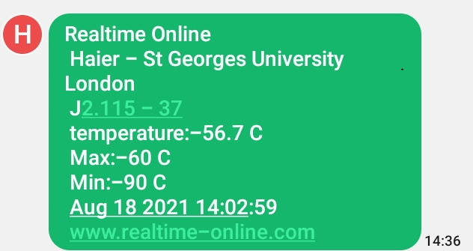

Email
with Time stamp, Sensor Input, low and a high temperature limit. The email will be from Invisible-systems - no-reply@realtime-online.com See example below.

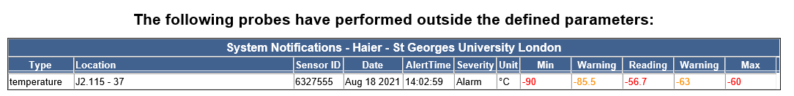

PLEASE NOTE : Please record your actions and any remedial work regarding this notification by logging into your realtime-online web portal. No further warnings will be generated for the above sensor(s) for another 24 hours.

  - Viewing probe data.
    - Open any browser. Type in URL – https://www.realtime-online.com Log in with your Full Username and password.

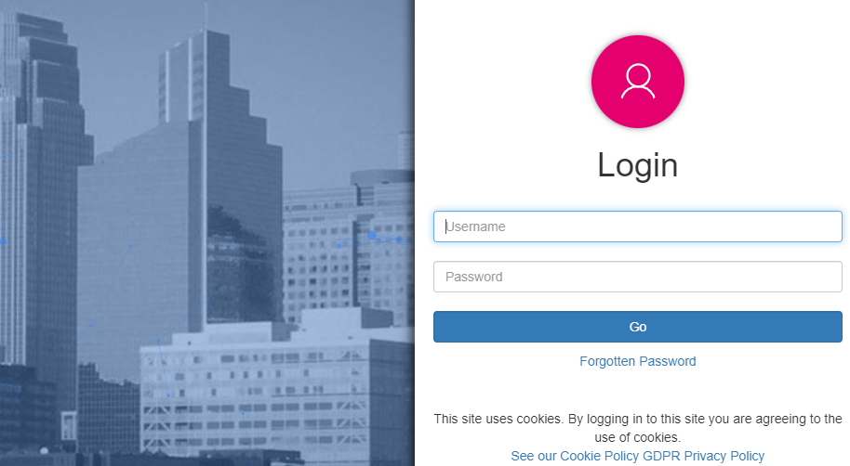

4.2.1 Once logged in you will see the alarm state of the freezer in flashing red.

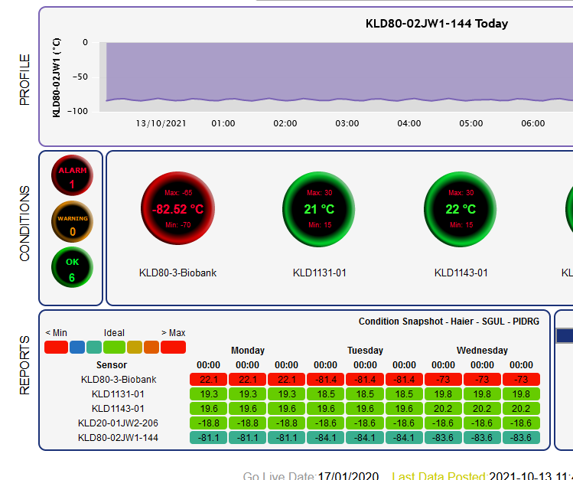

  - To cancel and acknowledge the alarm

    - Double-click on Date.
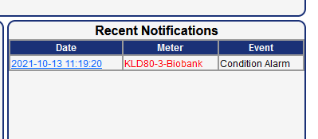
You will see details of the alarm

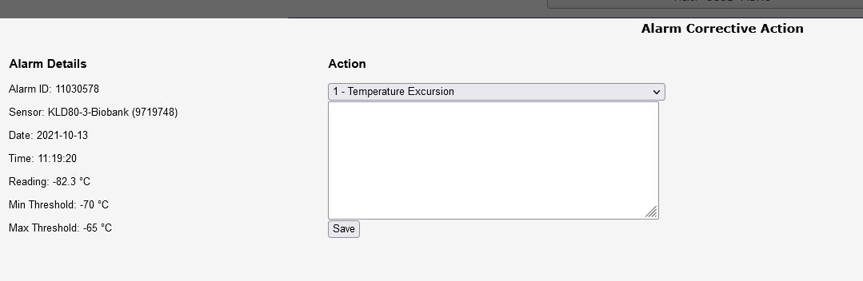

To acknowledge the alarm (turns green status from red) and record the actions undertaken, use the “Edit” button. This information entered will be used for audit purposes.
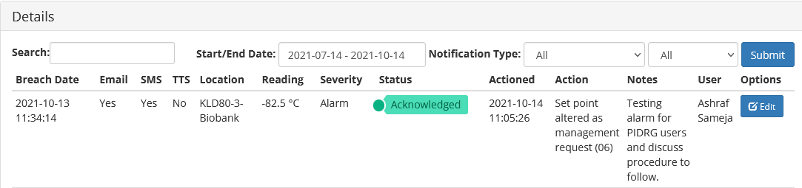

    - If you think the problem is a false alarm you can reset and enable.
    - If the situation requires inspection of the cold storage devices or probes, please contact your ‘on call’ partner to agree the required response – e.g. site visit
    - If you are arriving out of hours, please inform St. George’s University security on ext. 0909, giving your name and contact numbers so that they know you are on site. Upon arrival check the device.

  - Checklist
    - Check for power (section 4.5)
    - Check the appliance. If the door has been left open, close it and monitor the readouts to see if the temperature starts to fall.
    - If the door has not been left open, monitor the readouts to see if the temperature is falling or still rising. If the temperature continues to rise, implement the relevant disaster recovery SOP (check with your Manager).

  - The electricity and generator have failed
    - The appropriate fridges and freezers are on a supply connected to a back-up generator which maintains the supply in event of a shutdown. When the generator starts it may trip the alarm.
    - If the power has not been restored the University disaster recovery SOPs will be initiated.

4.6 Backup Emergency Freezer
If the freezer has failed, then you will need to rescue your samples by removing and placing them to the nearest Backup freezer. If this action is to be taken during Office hours, then please contact the Technical Research Operations Team (ext 0139) for assistance.

5 REFERENCE (See FLOW DIAGRAM on page 6)

CONTACTS

Penny Lympany | Head of Laboratory Services | Ext 1603 | plympany@sgul.ac.uk
Ash Sameja | Laboratory Manager | Ext 2428 | asameja@sgul.ac.uk

Freezer Alarm FLOW DIAGRAM

Alarm Activated
Report to Estates & Facilities
For Electric /Air condition failure

Has someone opened door?

Phone call
Out of Office Hours
Check on-line
Check Graph readings
Check with reception (0909) if there has been power failure
Allow 30mins
For freezer to settle
Check on PC (Haier)
Or
Physically check freezer
Transfer samples to Emergency Freezer
1) Is LED display on?

2) Check mains power cable plugged in?

Email & Phone Alert
Office Hours
Make your way to University
YES
NO
No
Yes

