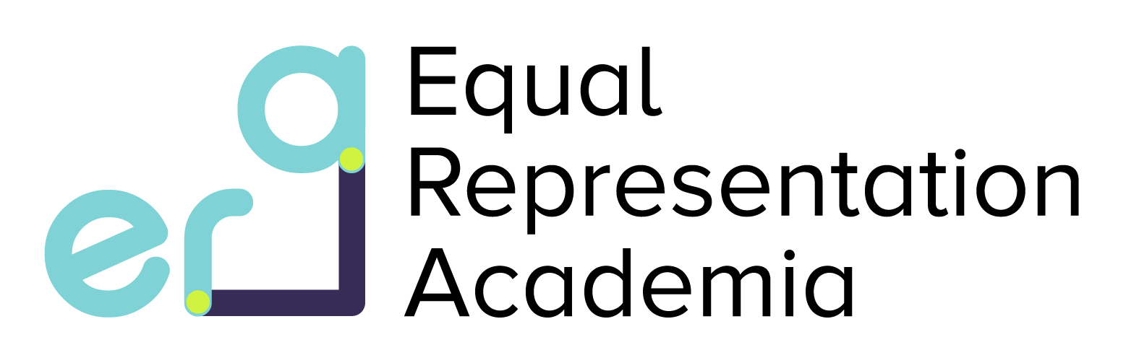ERA Summer Studentships (6-8 weeks)
2023 Project List

- Supervisor: Tom Hall et al (thall@sgul.ac.uk)
Project title: Measuring SARS-CoV-2 antibodies against S1, S2, RBD and N antigens in mothers and their neonates.
- Supervisor: Deborah Chong (dchong@sgul.ac.uk)
Project Title: Does leptin and ghrelin contribute to lung damage in Tuberculosis?
Please note, only 1 candidate will be awarded an ERA studentship this year.
What is ERA?
ERA is an initiative which is working to improve the representation of underrepresented groups in research, retain diverse talent and create an inclusive environment for all. Please read more about the ERA initiative here: https://www.sgul.ac.uk/research/era
What is an ERA studentships?
ERA studentships provide you with the opportunity to get hands on research experience. You will be able to design a project with a supervisor of your choosing and write a research proposal. The work you conduct during this studentship will contribute towards research output e.g., a research paper, conference submission and/or internal presentation. This is fantastic opportunity for you to grow your research interest and cultivate your research network.
Vacation Studentships provide the opportunity to gain valuable research experience in a laboratory at SGUL, with the intention of encouraging students to consider a career in research.
Eligibility:
The initiative is open to students from underrepresented backgrounds. If you receive any grants or bursaries from the university and/or are registered with the disability service and/or are from an ethnic minority background (https://www.ethnicity-facts-figures.service.gov.uk/style-guide/writing-about-ethnicity), you are eligible to apply.
Timeline:
The placements will take place between June – September 2023. You will agree on a start date with your supervisor.
Award:
You will receive a stipend at the same level as Wellcome Trust Studentships (£250 per week). The host laboratory will also be provided with funding to cover the cost of consumables and/or research output.
How to apply:
If the projects above interest you, contact the supervisor and develop a project proposal. If you are interested in taking on a studentship with a lab host that is not on the project list, please contact them directly regarding this opportunity. Once you have agreed on a project proposal and start date with them, please document these details in your ERA application form below.
Complete the form below and submit to Dr Mohani Dhillon (mdhillon@sgul.ac.uk) by 8th May 2023 at 4PM. Late applications will not be considered.
How you are marked:
You will be considered primarily on the basis of the application form, not previous academic performance. Applications will be marked by judges. Once you have been shortlisted, you will be invited for a short informal interview before the final decision is delivered.

Application form questions for ERA Summer Studentships 2023:

- Please specify which eligibility criteria you meet (delete as appropriate):
  - I receive an SGUL grant / bursary.
  - I am registered with the disability service.
  - I am from an ethic minority background.
- Contact details
  - Name
  - Course
  - University Year of study
- Proposed dates and duration of project
- Title of project
- Give a brief outline of your proposed research (500 words maximum)
- What does ensuring Equality/Equity, Diversity and Inclusion in research mean to you? (300 words)
- What are your career aims and how would this studentship help you achieve them? (400 words maximum)

