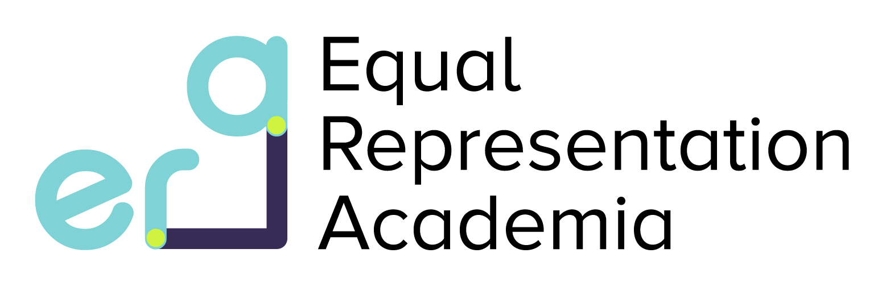
Work Shadowing Placements (2 weeks)
2023 Project List

- Supervisors: Dr Dan Osborn, Dr Alan Pittman, Dr Laura Southgate (PI)
Project title: The pipeline of gene discovery in rare disease.
- Supervisor: Dr Audrey Teh
Project Title: Producing cancer therapeutic drugs in tobacco plants.
- Supervisor: Dr Deborah Chong
Project Title: Does leptin and ghrelin contribute to lung damage in Tuberculosis?
- Supervisor: Dr Anissa Chikh
Project title: Targeting novel modulators of ADAM17 in skin homeostasis and cutaneous squamous cell carcinomas c(SCC).
- Supervisor: Tom Hall et al
Project title: Measuring SARS-CoV-2 antibodies against S1, S2, RBD and N antigens in mothers and their neonates.
- Supervisors: Dr Ferran Valderrama and Dr Clara Cieza-Borrella
Project title: Analysis of 3D cell culture spheroids recapitulating the glandular region of the prostate in a model of prostate cancer.
- Supervisor: Dr Lucia Ricciardi
Project title: Interoception based training for Parkinson’s disease.
- Supervisors: Dr Mark Bodman-Smith and Dr Mohani Dhillon
Project title: The role of unconventional T cells is cancer immunotherapy & use of MRI to image cancerous brain tumors.
Please note, 4 candidates will be awarded an ERA work shadowing placement this year. This figure includes students from external universities.
What is ERA?
ERA is an initiative which is working to improve the representation of underrepresented groups in research, retain diverse talent and create an inclusive environment for all. Please read more about the ERA initiative here: https://www.sgul.ac.uk/research/era
What is an ERA work shadowing placement:
ERA work shadowing placements provide you with the opportunity to gain a valuable insight into academic research careers. The placements are almost like a “try before you buy” experience. You will shadow a research group to understand the day-to-day life of members instrumental to the scientific process including but not limited to, postgraduate students, postdoctoral fellows, laboratory technicians, lab principal investigators (PIs) and professors. You may also be involved in the group’s research practices, allowing you the opportunity to develop a research network. You will experience academic activities from grant writing to lab experiments and you will work personally with a careers advisor to review your CV.
Eligibility:
The initiative is open to students from underrepresented backgrounds, in the first and second year of their degree. If you receive any grants or bursaries from the university and/or are registered with the disability service and/or are from an ethnic minority background (https://www.ethnicity-facts-figures.service.gov.uk/style-guide/writing-about-ethnicity), you are eligible to apply.
Timeline:
The placements will take place between June – September 2023. You will agree on a start date with your supervisor.
Award:
You will receive a stipend at the same level as Wellcome Trust Studentships (£250 per week). The host laboratory will also be provided with funding to cover the cost of consumables and/or research output.
How to apply:
Complete the form below and submit to Dr Mohani Dhillon (mdhillon@sgul.ac.uk) by 8th May 2023 at 4PM. Late applications will not be considered.
How you are marked:
You will be considered primarily on the basis of the application form, not previous academic performance. Applications will be marked by judges. Once you have been shortlisted, you will be invited for a short informal interview before the final decision is delivered.
Optional:
If you are interested in taking on either a 2 week work shadowing placement or studentship (there is a separate form for this) with a lab host that is not on the project list, please contact them directly regarding this opportunity. Once you have agreed on a project and start date with them, please put these details in your ERA application form below.

Application form questions for ERA Work Shadowing Placements 2023:

- Please specify which eligibility criteria you meet (delete as appropriate):
  - I receive an SGUL grant / bursary.
  - I am registered with the disability service.
  - I am from an ethic minority background.
- Contact details
  - Name
  - Course
  - University Year of study
- What does ensuring Equality/Equity, Diversity and Inclusion in research mean to you? (400 words maximum)
- What are your career aims and how would this placement help you achieve them? (400 words maximum)
- Based on the project list on page 1, which project would you like to undertake and why? (400 words maximum)

