Unitu SSPG Report
Introduction
Unitu is a digital student voice platform where students, Year Reps, and staff can collectively raise, discuss, and resolve academic and wider student experience issues, as well as praising initiatives and people at St George’s or post ideas that would benefit others. More information about Unitu can be found on the University’s webpages.
At St George's, Unitu was first introduced in November 2019, with all students having access to the platform from February 2020. Student engagement with Unitu has been consistent with peak points in April 2020 and January 2021.
This Student-Staff Partnership Grant (SSPG) was introduced to better understand student’s perceptions of Unitu. Aside from a focus group in June 2020 and Unitu’s own internal survey from July 2020, wider student feedback about the platform is limited.
This report highlights the findings of the student survey and focus groups as part of the SSPG; before summarising the findings and stating recommendations.
Comments from the focus groups have been used to supplement the findings from student survey.
Participants
Survey participants
249 students completed the Unitu student survey between 26th March and 21st June 2021. The programme and year of study from the survey respondents can be found below.
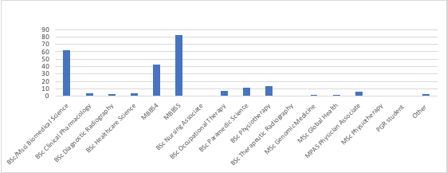Fig 1. Programme of study for the survey respondents.
As Fig 1 demonstrates, the vast majority of respondents studied MBBS5 (83), BSc/MSci Biomedical Science (63) or MBBS4 (43).
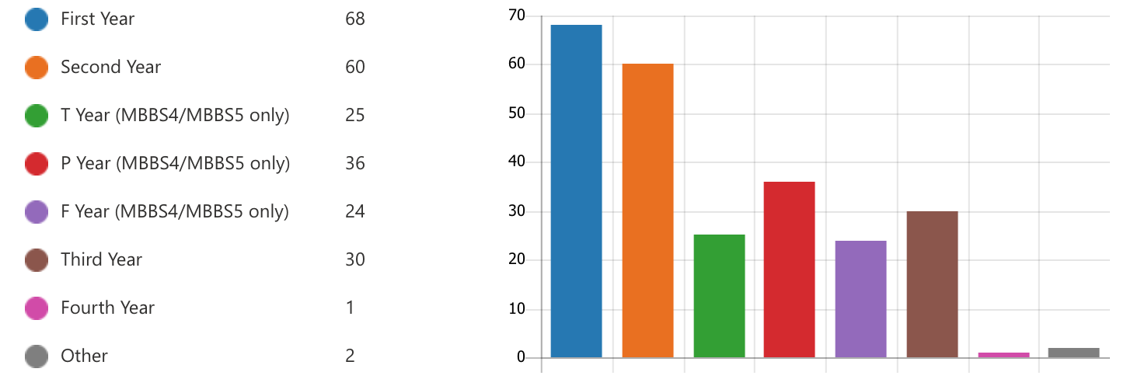
Fig 2. Year of study for the survey respondents.
As Fig 2 demonstrates, virtually all year groups had a good level of representation as part of the student survey. The ‘Fourth Year’ student studied MBBS5 and the two ‘Other’ respondents included an Intercalated BSc and In-Service Paramedic Service student.
Focus group participants
22 students were recruited to participate in focus groups. The focus groups were used to unpick the initial findings from the student survey and explore key themes which the SSPG core researchers wanted to explore. The programme of study for the focus group participants can be found below:
Course of study | No. of participants
BSc Biomedical Science | 3
MBBS4 | 7
MBBS5 | 6
BSc Paramedic Science | 3
BSc Physiotherapy | 2
BSc Therapeutic Radiography | 1
Fig 3. Programme of study for the focus group participants.
How often do students use Unitu?
Respondents were asked how frequently they use Unitu. As Fig 4 indicates, most students use Unitu on a weekly basis or when there is post they want to interact with (27% each).
36 respondents (15%) had not previously used Unitu. In comparison, 35% of St George’s students have not activated their Unitu accounts. This shows that students responding to the survey tended to be more engaged with Unitu than the average St George’s student.
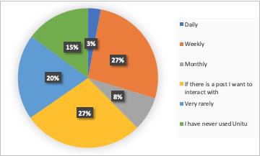
Fig 4. Frequency of use amongst respondents.
The same data is presented in Fig 5 in ascending order from most positively perceived to most negatively perceived.
Frequency of use | No. of responses
If there is a post I want to interact with or a post I want to create | 70
Weekly | 67
Very rarely | 49
I have never used Unitu | 36
Monthly | 19
Daily | 7
Fig 5. Frequency of use amongst respondents in ascending order.
Of the 36 respondents who had never used Unitu, their reasons for not engaging can be seen in the table below.
Reason for not engaging | No. of responses
Feels like a lot of hassle | 12
I do not understand the aim of the platform | 13
I would prefer to speak to my lecturer / tutors directly | 14
It would not help me | 6
Negative perception of the platform | 3
Unsure if my feedback is meant for Unitu | 1
Unsure how to create an account | 2
There are other ways in which I can make my voice heard | 5
Fig 6. Reasons why those who have not used Unitu did not engage with the platform.
As illustrated by Fig 6, some respondents have not engaged with Unitu because it feels like a lot hassle, they do not understand its aim or they prefer to communicate with members of staff in another way. This is reinforced by some qualitative comments from the student survey:
‘Just seems like an extra thing to have to use when emails work fine enough’ (MBBS4, Year 1)
‘I need to find ways wherever possible to reduce my internet use - for my mental health’ (MBBS4, P Year)
‘I do prefer to speak to my course reps or lecturers if i do have issues. It just seems easier, I don't want other students to misconstrue my feedback or the issues I have.’ (BSc Paramedic Science, Year 2)
How have you engaged with Unitu so far?
As demonstrated in Fig 7, of the 213 respondents who had engaged with Unitu previously, 92% of them had read a post on Unitu, a further 77% of students had upvoted or downvoted a post. These are passive forms of engagement whereby a student does not need to comment or create a post. 46% of respondents posted a comment and 32% created a post. These are active forms of engagement whereby a student is giving their opinion. 5% of respondents had reported a post or comment, these are our ‘student leaders’ who are able to see right and wrong and call out negative behaviour.
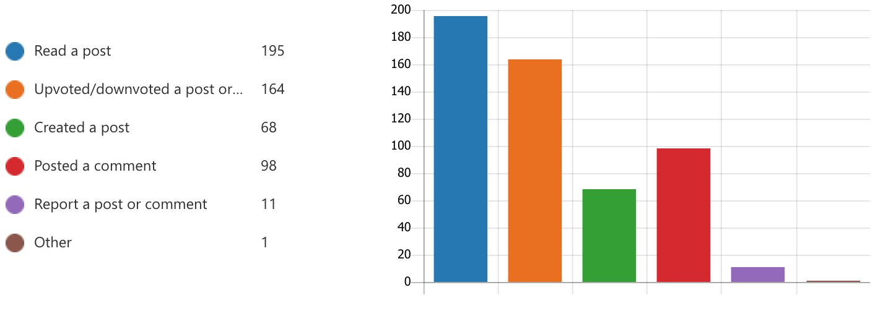
Fig 7. Respondent’s types of engagement on Unitu.
Overall perceptions of Unitu
Fig 8 provides a visual representation of respondent’s overall perceptions of Unitu.
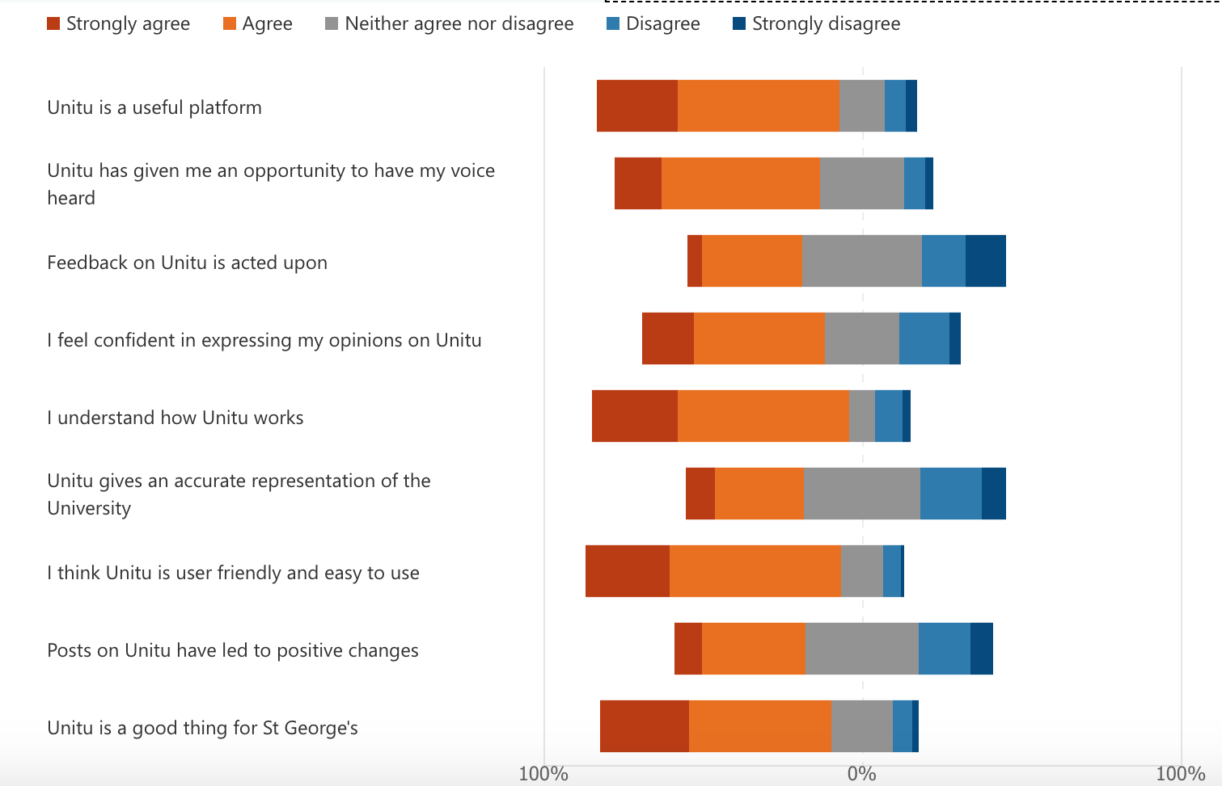
Fig 8. Respondent’s overall perceptions of Unitu.
The same data is presented in Fig 9 in ascending order from most positively perceived to most negatively perceived.
Indicator | Positive response (Strongly agree + Agree)
I understand how Unitu works | 81%
I think Unitu is user friendly and easy to use | 80%
Unitu is a good thing for St George's | 73%
Unitu is a useful platform | 71%
Unitu has given me an opportunity to have my voice heard | 65%
I feel confident in expressing my opinions on Unitu | 58%
Posts on Unitu have led to positive changes | 41%
Unitu gives an accurate representation of the University | 37%
Feedback on Unitu is acted upon | 36%
Fig 9. Respondent’s positive perceptions of Unitu in ascending order.
Respondents found the platform easy to navigate and user-friendly, respondents were also generally positive regarding the usefulness of the platform, highlighted in green as part of Fig 9.
‘I think Unitu is great and has really helped to highlight some issues. Sometimes stuff is raised which can't be fixed but overall its introduction has been much welcomed.’ (Paramedic Science, Third Year)
‘Unitu is the single greatest thing the uni has done since I’ve been here’ (MBBS4, T Year)
‘Unitu is a powerful tool for shaping the course/curriculum especially since the pandemic.’ (Biomedical Science, Year 2)
Respondents had a somewhat positive perception of Unitu’s ability to allow respondents to express their opinions, highlighted in yellow as part of Fig 9.
‘I think Unitu is such a great platform, it literally gives students a voice, the issues need to be ironed out and it will be perfect’ (Diagnostic Radiography, Year 2)
‘Unitu is an excellent platform to do that (get student voices heard)’ (Biomedical Science, Year 3)
Respondents had a negative perception of content on Unitu being acted upon and leading to positive changes, highlighted in red as part of Fig 9.
‘Feedback is too slowly responded to’ (Biomedical Science, Year 2)
‘staff are not interested in making such changes (where there are cases I've seen it would be understandable why, but most cases it's unacceptable and quite frankly, pathetic).’ (MBBS5, T Year)
‘it feels like student’s voices are heard but I would say that there have been issues this year where points have been raised and posts have been made, but sometimes it takes staff long to respond’ (Diagnostic Radiography, Year 2)
‘it seems that unitu merely serves as a platform for students to vent about problems at St Georges so that the university can say that they 'listen to the students'. I am not aware of any serious issues that have been raised on Unitu and have been concluded in a way that the students felt beneficial.’ (Biomedical Science, Year 3)
Fig 9 highlights some interesting results. The work of those overseeing Unitu’s implementation, should focus on the platform’s ability to lead to positive changes.
Respondent’s perception of Year Rep’s role on Unitu
Fig 10 provides a visual representation of respondent’s overall perceptions of Unitu.
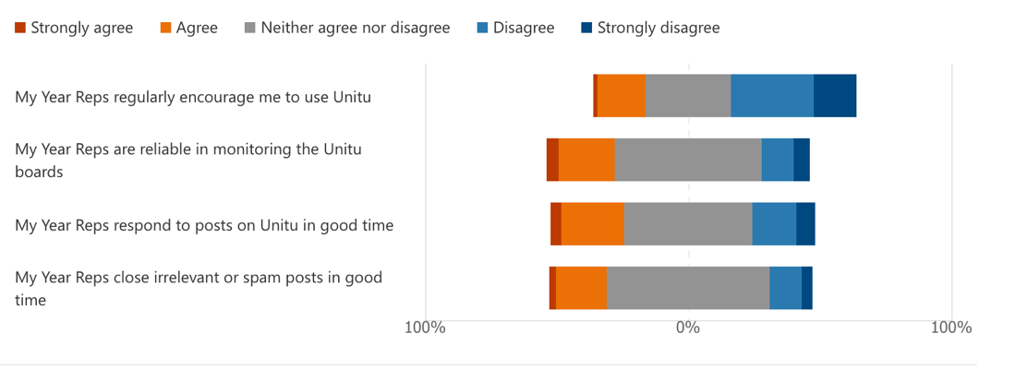
Fig 10. Respondent’s perceptions of Year Rep’s involvement with Unitu.
The same data is presented in Fig 11 in ascending order from most positively perceived to most negatively perceived.
Indicator | Positive response (Strongly agree + Agree)
My Year Reps respond to posts on Unitu in good time | 28%
My Year Reps are reliable in monitoring the Unitu boards | 26%
My Year Reps close irrelevant or spam posts in good time | 22%
My Year Reps regularly encourage me to use Unitu | 20%
Fig 11. Respondent’s perceptions of Year Rep’s involvement with Unitu in ascending order.
The vast majority of students had a negative view of Year Rep’s involvement with the platform. The most popular answer for the four questions related to section was ‘neither agree nor disagree’, which indicates that the wider student body do not fully understand the role Year Reps play within Unitu. This is perhaps unsurprising as the majority of Unitu promotion up until now has focused on account activation; as opposed to the role which staff and Year Reps play on the platform. Students have also had reduced contact time with their peers of the past 16 months, as a result, they have spent less social and educational time with their Year Reps.
However, there was some praise for the role which Year Reps played on Unitu as part of the focus groups:
‘I feel like last year our Year Reps were quite good but this year they’re not as good at getting back to you quickly about things you need clarification on.’ (MBBS4, P Year)
‘if you have a good Year Rep they spend a lot of time doing that stuff’ (MBBS5, Year 2)
‘So move Year Reps’ role on to Unitu rather than being a focal point for everyone’s concerns.’ (Physiotherapy, Year 2)
‘Being a second year, our year reps are quite on it.’ (MBBS5, Year 2)
‘I only heard of Unitu last year, I’m on the MBBS4 course and I heard about it from our Year Rep’ (MBBS4, P Year)
Negativity on Unitu
Negativity on Unitu refers to rude/personal/offensive/spam posts and comments which are directed towards staff, Year Reps and/or other students. Negativity on Unitu has typified the early implementation of the platform and resulted in a significant amount of reported content whilst having an impact upon staff and Year Rep’s wellbeing and motivation to engage with the platform. Fig 12 provides a visual representation of respondent’s perceptions of some of the negative aspects of Unitu. 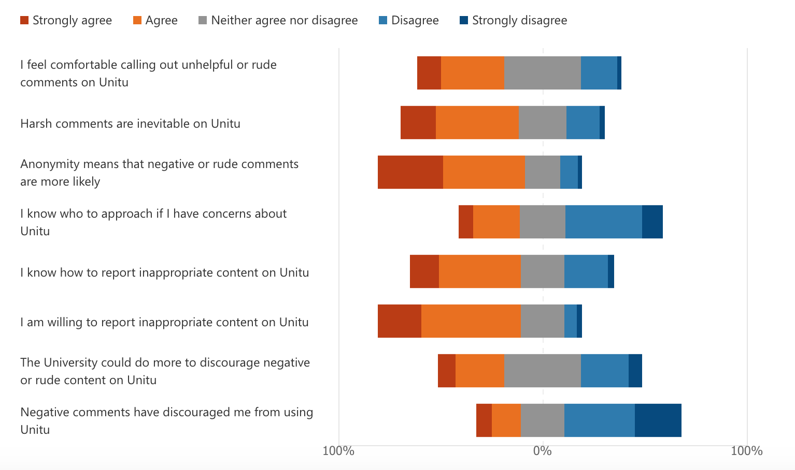
Fig 12. Respondent’s perceptions of negative aspects of Unitu.
The same data is presented in Fig 13 in ascending order from most positively perceived to most negatively perceived.
Indicator | Positive response (Strongly agree + Agree)
Anonymity means that negative or rude comments are more likely | 72%
I am willing to report inappropriate content on Unitu | 70%
Harsh comments are inevitable on Unitu | 58%
I know how to report inappropriate content on Unitu | 56%
I feel comfortable calling out unhelpful or rude comments on Unitu | 43%
The University could do more to discourage negative or rude content on Unitu | 33%
I know who to approach if I have concerns about Unitu | 30%
Negative comments have discouraged me from using Unitu | 22%
Fig 13. Respondent’s perceptions of negative aspects of Unitu in ascending order.
A narrative is developing regarding some of negative aspects of Unitu. Respondents feel that anonymity does lead to negativity and rudeness on the platform with students feeling comfortable calling out inappropriate content.
More support needs to be given to students, so they feel confident calling out inappropriate content and know who to contact if they have concerns about Unitu. It is interesting that 22% of respondents have been discouraged from using Unitu, a cultural change is required for these students to re-engage with the platform.
Respondent’s perception of staff’s role on Unitu
Fig 14 provides a visual representation of respondent’s perception of staff’s involvement on Unitu.
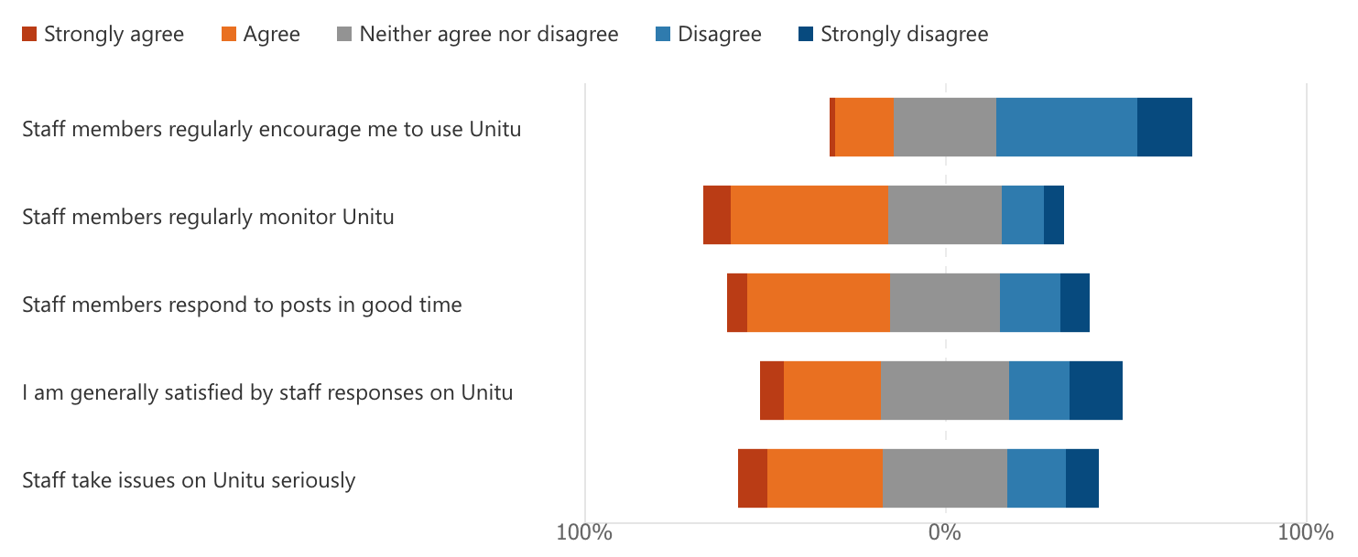
Fig 14. Respondent’s perceptions of staff’s involvement with Unitu.
The same data is presented in Fig 15 in ascending order from most positively perceived to most negatively perceived.
Indicator | Positive response (Strongly agree + Agree)
Staff members regularly monitor Unitu | 51%
Staff members respond to posts in good time | 45%
Staff take issues on Unitu seriously | 40%
I am generally satisfied by staff responses on Unitu | 33%
Staff members regularly encourage me to use Unitu | 17%
Fig 15. Respondent’s perceptions of staff’s involvement with Unitu in ascending order.
Although respondent’s perceptions of staff involvement with Unitu was better than that of Year Reps, respondents were not satisfied with staff’s involvement with the platform. Open text comments from the survey also suggested that more can be done to strengthen the student and staff relationship on Unitu:
‘I have no idea who the staff are that reply to the messages. An introduction into their role would be nice’ (Diagnostic Radiography, Year 2)
‘The user board clearly shows majority of staff do not regularly access Unitu. Seeing that really dents the confidence of using the platform.’ (Occupational Therapy, Year 2)
‘I think there needs to be some progress on how unitu concerns are taken. It often feels like we are taking backwards steps in understand the student perspective, particularly when the issues are complex. It often comes across as if the concerns are dismissed.’ (MBBS5, P Year)
Anonymity
Anonymity is one of the most controversial aspects of Unitu. One of the platform’s key selling points is that it allows students to provide anonymous feedback which might not otherwise reach staff member’s attention. On the other hand, the anonymous nature of Unitu has been abused with rude/personal/offensive/spam posts and comments being directed towards Year Reps and staff; with students also being rude to one another in the comments section of some Unitu posts.
94% of posts on Unitu are created anonymously and the nature of posting anonymously is embedded in student culture. However, action does need to be taken to create a more positive and constructive environment for staff and students.
Fig 16 provides a visual representation of respondent’s perception of anonymity.
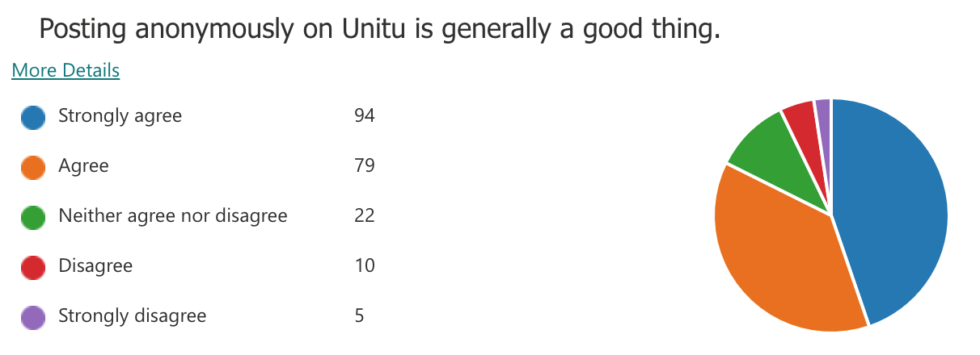
Fig 16. Respondent’s perception of anonymity.
The same data is presented in Fig 17 with percentages for each indicator displayed.
Indicator | Percentage of responses
Strongly agree | 45%
Agree | 38%
Neither agree nor disagree | 10%
Disagree | 5%
Strongly disagree | 2%
Fig 17. Respondent’s perception of anonymity by percentage.
As Fig 17 indicates, 83% of respondents gave a favourable response (Strongly agree or agree) regarding their perception of anonymity.
Feedback from the open text comments and focus groups indicated that respondents valued anonymity in order to post content which they would not wish to have their name attached to and felt that there would be reduced student engagement on the platform.
Positive comments about anonymity
‘Maybe if we didn’t have that feature there would be less individuals posting’ (MBBS5, F Year)
‘sometimes you feel weird about emailing a lecturer to be like ‘that lecture was really good!’ and so the anonymity or being able to thumb up but being able to show appreciation for really great staff members is really great.’ (Clinical Pharmacology, Year 2)
‘I think anonymity means students feel they can speak their mind without repercussions.’ (Biomedical Science, Year 3)
‘Despite anonymity potentially leading to rude/harsh comments, it is vital for allowing students to voice concerns that they might not otherwise if their identity was not concealed.’ (MBBS5, Year 1)
In contrast, respondents felt that anonymity means that students cannot receive ongoing support, students should be accountable for their actions and other respondents highlighted the rudeness associated with the platform.
Negative comments about anonymity
‘It made me think that if you are struggling and you post anonymously, you might not get the support you need because you are anonymously. If someone is repeatedly posting and they are anonymous, they are never really going to get that pastoral care that they need.’ (MBBS4, T Year)
‘I’ve read some quite surprising comments on Unitu where students have abused anonymity to say some rude and cutting things.’ (Biomedical Science, Year 2)
I feel like the anonymous button on unitu allows people to be overly negative/ rude without being held accountable for it. If you are being professional I don't see the need to be able to comment anonymously. (MBBS5, F Year)
Culture of Kindness
Respondents were asked ‘On a scale of 1-10 (1 being extremely negative and 10 being extremely positive), how would you rate the culture of kindness on Unitu?’ The average response was 6.08/10, which was higher than expected, given the amount of negativity surrounding the platform. The modal response was 7 out of 10, with 53/211 (25%) of respondents selecting this option.
Tone-checking feature
Unitu also introduced a new tone-checking feature in February 2021. New posts and comments are filtered through Unitu’s tone checking feature which is powered by Google Sentiment Analytics. If any new content is deemed to be inappropriate by the system, it will create a pop-up and ask the user whether they want to proceed with posting the content. Respondents were asked whether they found this feature useful or not.
Fig 18 provides a visual representation of respondent’s perception of the tone-checking feature. 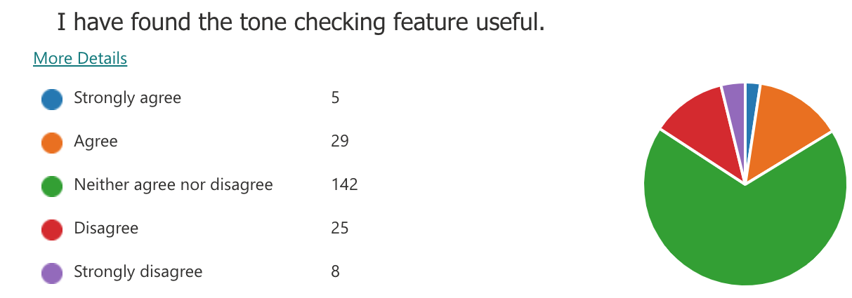
Fig 18. Respondent's perceptions of the tone-checking feature.
The same data is presented in Fig 19 with percentages for each indicator displayed.
Indicator | Percentage of responses
Strongly agree | 2%
Agree | 14%
Neither agree nor disagree | 68%
Disagree | 12%
Strongly disagree | 4%
Fig 19. Respondent's perceptions of the tone-checking feature by percentage.
As indicated by Fig 19, 68% of respondents answered ‘neither agree nor disagree’ regarding their perception of the tone-checking feature. There were no additional qualitative comments referencing the tone-checking feature throughout the whole qualitative data set. This suggests that the tone-checking feature has not had a significant impact upon student’s interactions with Unitu, or not enough students have had experience of the tone-checking feature.
Open Text Comments
For the final three questions of the survey, respondents were asked to state positives, negatives and possible improvements which could be made on Unitu.
Positives
Gives students a voice
‘Being able to raise potential issues or queries and gain a response from the most appropriate person in a respectable time frame’ (Paramedic Science, Year 2)
‘It's a great way to have my voice heard’ (Physiotherapy, Year 1)
‘The fact that it allows students to raise their issues and most of the time they are heard and acted on’ (MBBS5, Year 1)
‘Being able to share your thoughts and opinions and know that if you speak for a majority’ (Paramedic Science, Year 1)
Direct contact with staff
‘Being able to have direct contact to University staff and be able to express concerns/praises’ (Biomedical Science, Year 2)
‘Staff respond fairly quickly. Much faster than emails.’ (MBBS5, F Year)
‘So much more immediate in terms of addressing issues and getting a response - when compared with eg feedback forms at ends of placements or annual surveys that disappear into a bit of a black box.’ (MBBS4, T Year)
Anonymity
‘It allows anonymity and student voice to be heard’ (MBBS5, F Year)
‘It's anonymous so students aren';t afraid to voice their opinions, and having a like and dislike button comes to show how many people experience the same issues.’ (Biomedical Science, Year 1)
‘Being able to express concerns or see that other people may have the same concerns as you - this can be validating.’ (MBBS4, T Year)
‘Allows you to freely express any concerns about exams/modules/teaching methods etc. without having to worry about if people disagree with you or not (due to being anonymous).’ (Biomedical Science, Year 2)
Feeling part of a community
‘Connection with the wider University peers and staff.’ (Physiotherapy, Year 3)
‘It makes you feel more connected to other students - it is nice to see where students are also struggling and validates when the university need to do more to support’ (MBBS4, T Year)
‘It's nice to see what people's concerns are, awareness is always a good thing.’ (MBBS4, T Year)
Negatives
Anonymity
‘Anonymous feedback creates toxic environment.’ (Paramedic Science, Year 2)
‘Anonymity promoting negativity. This feature is still necessary for self-protection at times, but should be used wisely.’ (Biomedical Science, Year 2)
‘anonymous responses allow harsh comments to be made, however the benefits of anonymity outweigh the negatives.’ (MBBS5, Year 1)
Unprofessional usage of the platform
‘The nastiness of some students, really horrible comments were made on there last year (I'm not sure if this is still the case as I use it far less now)’ (MBBS5, F Year)
‘Some ridiculous suggestions and real nastiness especially directed at staff.’ (MBBS5, P Year)
‘The whole thing seems like a giant whinge fest; I feel sorry for the university.’ (MBBS5, P Year)
Feedback not being acted upon
‘Not all the concerns that arise are acted upon, even if a suggestion is given. Rather just an explanation is given, which doesn’t solve the problem.’ (Biomedical Science, Year 2)
‘Sometimes posts aren't answered correctly as people misinterpret the question asked in the original post.’ (MBBS5, Year 1)
‘When feedback is not taken into account and disregarded. Some staff feedback also comes across as insensitive at times.’ (MBBS5, T Year)
‘Poor feedback loops, and how transparent it has become that it is extremely difficult to influence change particularly within courses.’ (MBBS5, P Year)
The app is not user friendly
‘It is a bit clunky, I miss speaking to staff and students in person’ (Paramedic Science, Year 1)
‘not as easy to use’ (Diagnostic Radiography, Year 2)
‘Confusing to use’ (Biomedical Science, Year 2)
Improvements
Improved staff responses
‘improved response time of staff to issues’ (MBBS4, T Year)
‘Turnaround time for staff replies have decreased noticeably.’ (MBBS5, Year 2)
‘Staff have to use the platform better - there's no point having it and voicing students opinions if it won't be acted on’ (MBBS4, P Year)
Remove anonymity
‘Remove the anonymous feature’ (MBBS4, T Year)
‘Taking anonymity off with less strikes.’ (Biomedical Science, Year 3)
‘Even if posting anonymously there should be a way that a dedicated supervisor or individual is able see who posted the comment in instances where there are issues of bullying or constant negative comments.’ (MBBS5, Year 1)
Improved student resources and wider usage
‘It would be useful to get a reminder of how it works, because sometimes comments are left up and they do the damage before they are removed and I can’t remember how it works.’ (MBBS5, P Year)
‘maybe more information being spread to students to use it; not enough people know about it.’ (Occupational Therapy, Year 2)
‘Encourage more people to utilise unitu to better represent the student body’ (MBBS4, P Year)
Improved user interface and friendliness
‘The layout is sometimes quite confusing’ (MBBS5, Year 1)
‘Make it more user friendly! It’s very confusing and not always used very well by people so it deters people from using it’ (Physiotherapy, Year 1)
‘Filter button. That way you can see whether a question has been asked before.’ (Physiotherapy, Year 1)
‘Not receiving so many email notifications about everything.’ (Biomedical Science, Year 3)
Summary
Undertaking this SSPG has been a valuable experience. It has been revealing to hear student’s perceptions of Unitu in a formalised way for the first time.
Unitu has been widely used by Biomedical Science and Medicine students with sporadic usage within the Centre for Allied Health. This is reflected in the sample frame of this piece of research. Students have a favourable view of Unitu, with 73% of respondents believing that Unitu is a good thing for St George’s. 71% of respondents also felt that Unitu is a useful platform. This indicates that Unitu has the potential to be successful at St George’s, if issues regarding anonymity are addressed through promoting a positive, professional and constructive culture.
The respondents to this research are generally highly engaged students who are knowledgeable about Unitu. 85% of respondents to the survey and all focus group participants had experience of using the platform; whereas 65% of St George’s students had activated their Unitu accounts.
Students tend to use Unitu on a weekly basis (27%) or when a post has been created which they wanted to interact with (27%). This supports general patterns of engagement, whereby more students use the platform when key issues related to the student experience arise; for example, decisions on OSCEs, exam feedback, transition to online learning in April 2020, University announcements and changes in government policy in response to Covid-19.
Of the 213 students who had interacted with Unitu, the vast majority had read or upvoted/downvoted a post. These are passive and convenient forms of engagement. Whereas creating a post, posting a comment or reporting a post or comment has a fundamental impact upon the content which appears on Unitu and are more active forms of engagement with the platform.
By looking into the quantitative data further, it is clear that students value Unitu as a platform to be able to have their voice heard, but they feel that feedback is not acted upon in a timely manner or with resolutions made which do not meet their expectations. Similar findings were also found in the 2021 Student Experience Survey (SES) and National Student Survey (NSS), which is unsurprising as the same cohort of students also would have had the opportunity to participate in this research too.
Respondents had a negative perception of staff and Year Rep involvement with Unitu. This is something that needs to be addressed with staff and Year Reps being given adequate support, resources and time to encourage professional, solution-focused and positive usage of Unitu. More support needs to be given to students, so they feel confident calling out inappropriate content and know who to contact if they have concerns about Unitu. When introducing Unitu to the wider student body, the aim was to spread awareness of the platform. Moving forward, there will be a great focus on developing bespoke resources to support the key stakeholder users of the platform (staff, Year Reps and students).
Anonymity was an issue which students discussed, without prompt, in the survey and focus groups. Whilst 83% of respondents to the survey believed that posting anonymously on Unitu was generally a good thing, there were plenty of qualitative comments which highlighted the toxic culture which had been created by anonymous posting. Staff feedback has frequently shown anonymous posting to be detrimental to wellbeing and has led to disengagement with the platform. In the open-text comments outlined above, anonymity was seen as both a positive and a negative. For example, one student gave the answer ‘anonymity’ for Question 19 - ‘What is the worst thing about Unitu?’ and Question 20 ‘What is the best thing about Unitu?’. This student’s response typifies the lack of consensus regarding anonymity on Unitu.
There were other contradictions within the data collected as part of this research. For example, 80% of respondents believed that Unitu is user-friendly; however, one of the key themes highlighted by the negative open text box comments was that the app was not considered to be user-friendly. Contradictions in the data are not surprising, as there is not one single student experience; each student has their own unique set of circumstances and expectations producing a multiplicity of student experiences.
Respondents highlighted the following positive areas regarding Unitu: students having the opportunity to have their voices heard, anonymity, direct contact with staff and feeling part of a community. Respondents highlighted the following negative areas regarding Unitu: anonymity, unprofessional usage of the platform, feedback not being acted upon and the app not being user friendly. Respondents highlighted the following improvements which could be made to the platform:
Recommendations
Recommendation #1 Promoting a positive, professional culture
The SSPG Team firmly believes that an institution-wide approach needs to be taken to promote a positive, professional culture on Unitu. This will help to attract new users to the platform, re-engage students and staff who have disengaged with the platform and create a better environment for Year Reps and staff to operate in.
This is an overarching aim, which can only be achieved if the other recommendations below are considered and actioned.
Recommendation #2 Year Reps asking for feedback
When training Year Reps, they should be encouraged to proactively ask the students they represent for feedback. This could be for specific meetings or to deliver to module/year leads and course teams. This will demonstrate to students the role which Year Reps play on the platform and help to build trust between student representatives and the wider student body.
Recommendation #3 Staff introducing students to the platform
When the platform re-launches for the upcoming academic year, Year Leads and/or Programme Directors should immediately welcome students to the platform with positive messages encouraging students to use the platform in a constructive and professional manner.
Recommendation #4 Feedback workshops for staff
There is a disconnect between students and staff regarding what is expected from student feedback in terms of timeliness and actions taken. The qualitative comments which highlight areas of good and poor practice should be used to create workshops with staff users of Unitu to highlight how best to respond to posts.
Recommendation #5 Educating students on feedback processes
Educating students on how decisions are made at a University and programme level is essential to addressing gaps between students and staff. Looking at the qualitative comments from the survey, there are misconceptions on behalf of the student body about how decisions are made and the lengths which staff go to in order to respond to posts on Unitu in a clear and concise manner.
Recommendation #6 Developing comprehensive student induction materials
Comprehensive induction materials should be delivered at induction, with a focus on account activation, the power of the student voice, calling our inappropriate behaviour, highlighting avenues of support and creating a positive, professional culture.
Recommendation #7 Ongoing promotion of Unitu
In order to continue to maximise engagement and usage, Unitu should be promoted via an on-campus marketing campaign, a specific feedback week, digital resources on Canvas and case studies highlighting when student feedback has resulted in a positive change.
Recommendation #8 Anonymity
As the quantitative and qualitative data demonstrates, there is no clear consensus regarding the future of anonymity and whether it should be retained or removed. Any wholescale change is likely to displease a wide section of the student body and worsen relationships between staff and students.
As a result, the SSPG Research Team recommends that the University Board should be de-anonymised on a trial basis for the autumn semester. This trial period will allow the Unitu Steering Group to monitor engagement and the prevalence of inappropriate content over a prolonged period. The University Board has been selected because issues posted have tended to be of a less personal and sensitive nature, therefore students should still be willing to provide their feedback.
A review of the trial period will take place between December and early January with any amendments to anonymity to be implemented by the end of January 2022.

