Unitu ‘How to’ Guide
for Year Reps

What is Unitu?
Unitu is a digital student voice platform where students, Year Reps and staff can ask questions, give praise, post ideas, or raise, discuss and resolve both course-related and more general university issues.
Students will be able to post on a private board made up of students from their course and other courses within their department. Should a post receive significant engagement, a Year Rep will then pass the post on to a public board for staff to respond to.
Unitu will create a transparent platform for student-staff engagement and timely responses, complementing the existing annual Student Experience Survey (SES), National Student Survey (NSS) and modular Student Online Teaching Survey (SOLTs).
This guide will give you a basic overview of what Unitu is, but the best way to find out is to activate your account and try it out for yourself!
Below represents the principles of Unitu:
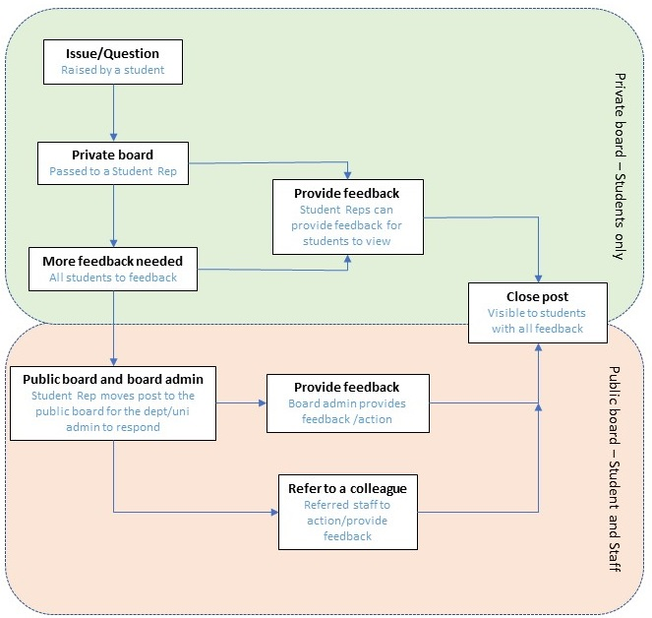

Aims of Unitu
- Provide a space for students to have their voices heard and feedback to be acted upon
- Produce a positive, constructive culture allowing for the facilitation of debate and a dialogue between students, Year Reps and staff
- Fit around existing student voice mechanisms, mainly annual surveys such as NSS and SES as well as modular surveys such as SOLTS
Your role
As a Year Rep, you will be able to see and interact with posts from students in your private departmental board. Your role is to moderate posts, encourage students to engage and feedback on posts where you can.
Once these posts have reached a ‘critical mass’ you can drag those posts in to the public board for academic staff to respond to. The idea is that widely and deeply felt issues are captured and feedback is given in a transparent way.
Not every course has a Year Rep, but if you feel able to do so you can respond to posts which are not your programme. Alternatively, you can always ask the original poster to contact their module or course leader.
Sometimes a post may be vague or not clear in what is wanted, it’s entirely ok to ask for more information. If you don’t get a response within a reasonable timeframe (a week is probably a fair amount of time) then feel free to close the post.
Please leave a few days after a post has been put up before interacting with it if it’s not from your course or year group, as there may be a background to the issue that you are not aware of. If the post passes the response deadline with no interaction then feel free to interact with it.
You can also request your own feedback ahead of any meetings you have with members of staff.
What is a critical mass?
A heavy workload is a widely felt issue which could impact a whole cohort. A deeply felt issue could be a student does not have access to Student Finance. Students can comment and up or down vote as a form of engagement with a post. Once a critical mass has been reached you can drag the post in to the ‘public area’ for staff to respond to.
A ‘critical mass’ is different for each course. As a general rule, once a post receives 5 more upvotes than downvotes it can be considered to have reached a ‘critical mass’. However, do use some common sense depending on the size of your cohort. If your year (or even course) group 30 students, 5 clearly much more significant than for a course where the year group is 200-300. Do discuss with other reps or the moderation team if you are unsure about whether to move something across or not.
What does Unitu look like?
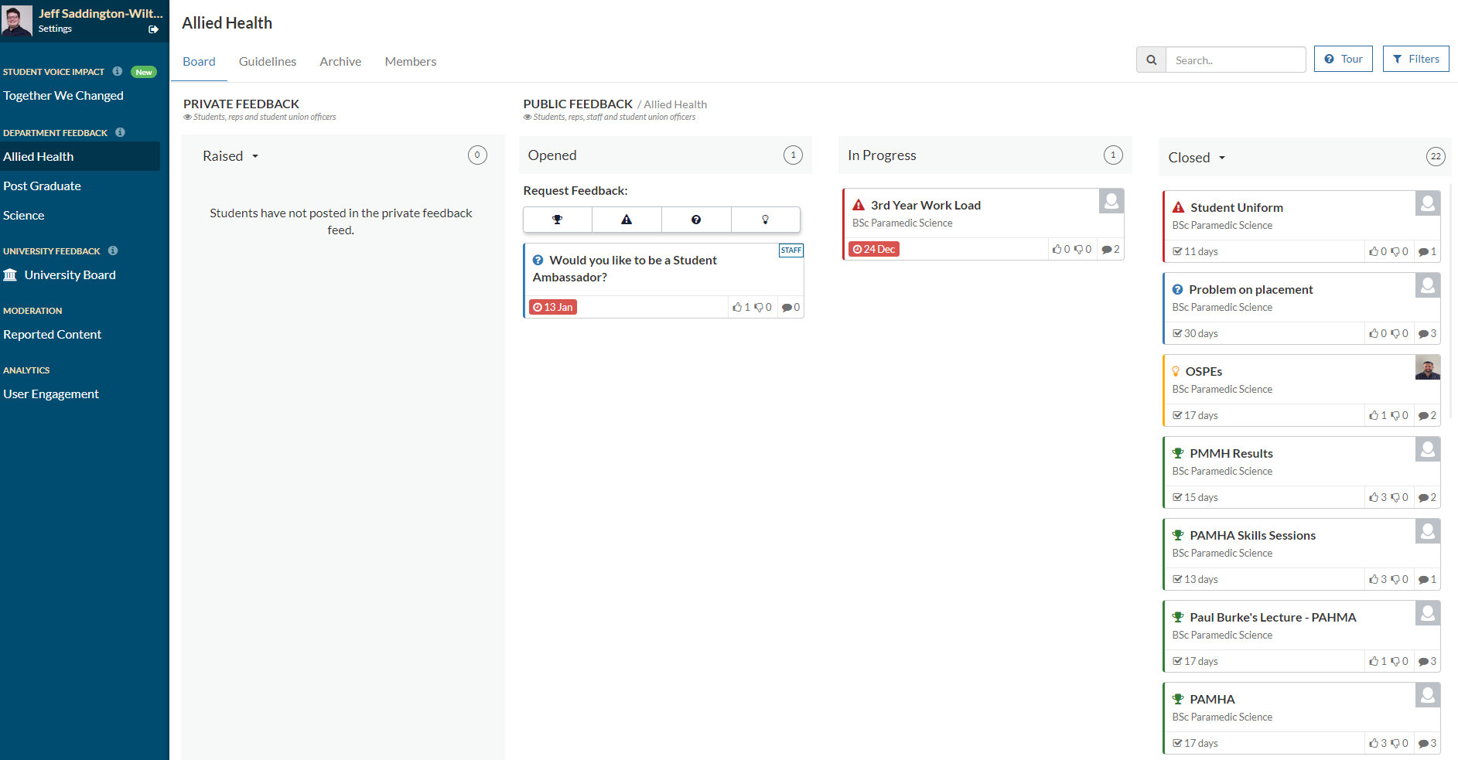

Unitu is essentially a discussion board split in to ‘private’ and ‘public feedback’. Whilst exploring Unitu, here are some key features to look out for:
Key feature | Description
Together we changed | See changes that were made across the University by students, staff and Year Reps.
Guidelines | See which staff are responsible for the boards, expected response times to posts and further links to how Unitu works.
Filters | There are plenty of filters to allow you to view posts which are relevant to you.
University Board | As well as your departmental board, you can also view and interact with the ‘University Board’ which will contain posts about the general student experience eg. funding, welfare.

What Unitu is and isn’t for
As Unitu is used by more and more people its purpose will become clear. Here are some examples which you can use when interacting with posts.
Suitable post | Unsuitable post | Where to go to instead
Positive feedback about a programme | An urgent Estates issue eg. flood on the ground floor | Estates helpdesk – estates@sgul.ac.uk
Staff member asking for feedback | A specific IT issue eg. Computer not working in Room H4.4 | IT helpdesk – itav@sgul.ac.uk
An issue regarding lack of food options on campus | Specific module query eg. When is this assignment due? | Module/Course leaders
An idea to have more guest lecturers | A complaint about a specific individual | Contact them privately to discuss the issue

What did we learn in Covid-19?
Covid-19 has created challenges for us all. An increase in posts and comments on Unitu was one of them, particularly for Year Reps and staff. During this time, the platform did not change but the way in which students engaged with it did.
If you are able to respond to and close a post in the private area, do so as this could save staff a lot of time and students will have increased belief and confidence in you!
During Covid-19, we also saw an increase in duplicated posts. You can close posts and refer students to existing posts if they include similar topics of discussion.
You will see a ‘report’ link under each post and comment. When you see content which could be considered rude/offensive, irrelevant or spam please report it so that the moderators can deal with it.
Quotes from previous Year Reps and students
"Unitu allows students to freely share their opinions and concerns about their teaching experience. Monitoring it can get a bit full on some times but is overall very rewarding.”

Fiona Donnan – MBBS Year Rep 2019-20

“Unitu allows you as a year rep to see what issues your cohort wants raised, that you may not already be aware of. It is important though to remember that you’re still a student and volunteer, so don’t feel that you need to spend a lot of time on the site responding to issues raised. Take a break every so often and make sure you’re making time for yourself!”

Ben Vickars – Paramedic Science Year Rep 2019-20

“Unitu has been useful to raise questions and issues about what interests me. Not everything is listened to and actioned but it is better than it has been in previous years.”

Biomedical Science, Year 2 student

How to activate your account
You should receive an email from Unitu asking you to activate your account.
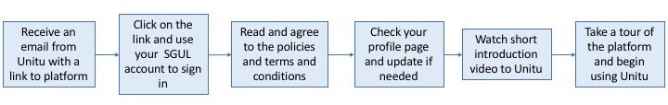
Alternatively, you can access Unitu via the student voice tile on your Canvas home page.
Key contacts
If you have any questions or concerns email experience@sgul.ac.uk
Further information
Head to https://unitu.co.uk/ for more information and case studies.
To find out the latest Unitu news at St Georges - https://www.sgul.ac.uk/for-students/your-academic-life/student-voice/unitu.
For more videos about Unitu - https://www.youtube.com/channel/UCqlHL8QwOR4tKBKlsHU9SeQ.

