St George’s, University of London

Public and Civic Engagement Strategy (2020-2024)

Public and Civic Engagement: Our Vision

At St George’s we are committed to improving human health and to making our research, scholarship and practice come to life in the world, engaging diverse groups of people.

Our approach is based on dialogue and partnership, fostering engagement between the University and the public at all stages of academic work, from design to delivery and evaluation.

We will create a sustainable culture where everyone within the University has the opportunity and support to do public engagement that is grounded in our research, education and practice strengths.

Our public and civic engagement will be original, effective, responsive and inclusive.

What is Public and Civic Engagement?

We have drawn on the National Co-ordinating Centre for Public Engagement (NCCPE) definition of public engagement in developing what public and civic engagement means at St George’s, University of London. The NCCPE describes engagement as:

"the myriad ways in which the activity and benefits of higher education and research can be shared with the public. Engagement is by definition a two-way process, involving interaction and listening, with the goal of generating mutual benefit."

Public engagement at St George’s reflects the spectrum of public engagement activities: to inform, to involve, to consult and/or to collaborate with the aim of enabling the widest possible range of audiences to engage with the University’s work locally, nationally and globally.

Who is the Public?

We interact with a wide range of people, groups and organisations. We value the diversity of our relationships and we take an inclusive approach to defining ‘the public’ for the purposes of our engagement work.

The public includes, but is not limited to:

- Patients
- Local residents and our neighbours
- Community groups
- Schools
- Charities
- Local partners
- Communities served by, or participating in, existing research both in the UK and internationally
- National organisations
- The media
- Audiences attending ideas festivals, arts events, demonstrations and exhibitions

Public and Civic Engagement at St George’s, University of London

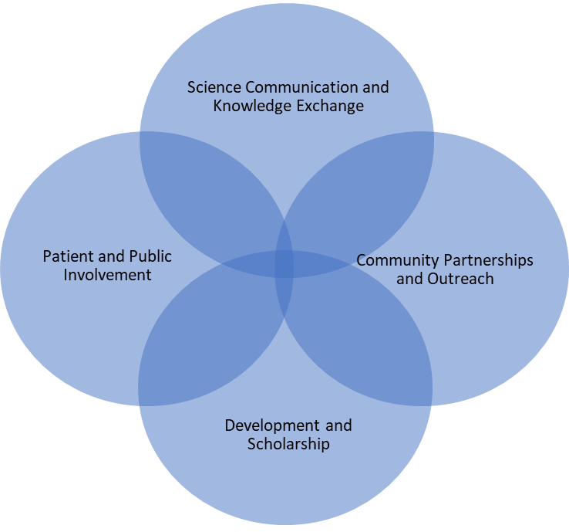
Public and civic engagement at St George’s, University of London is organised into four intersecting themes:

The four themes reflect the University’s strengths and portfolio of existing activities in public and civic engagement whilst allowing space for development and growth. The thematic structure is flexible, intended to provide a structure but not to limit or artificially segment effective public and civic engagement work at the University.

Public and Civic Engagement: Our Four Strategic Aims

We have four strategic aims for public and civic engagement at St George’s, University of London, namely to:

1. Build and embed a culture of public and civic engagement based on our four themes at St George’s, University of London;

2. Nurture existing partnerships and develop new relationships to facilitate novel public and civic engagement activities;

3. Provide support and a structured programme of development for any member of the University community who wishes to develop their interest and skills in public and civic engagement and

4. Achieve external recognition, funding and a national reputation for original, effective, responsive and inclusive public and civic engagement work in bioscience, health and medicine.

Achieving our Aims

To achieve our aims, we will undertake specific actions within the period of the strategy. The actions speak both to what we will do and how we will do it, recognising that the way in which public and civic engagement work is conducted is as significant as what is achieved. Our actions will reflect the underpinning values of inclusion, co-creation and responsiveness. Many of the actions are already underway, others are planned for development during the period of the strategy. All actions will be regularly reviewed by the working group reporting annually to Executive Board and, as required, to Council.

To build and embed a culture of public and civic engagement based on our four themes at St George’s, University of London, we will:

- Appoint an Associate Dean (Public and Civic Engagement) and a Public Engagement Officer;
- Create a community, working with the public engagement officer, Associate Dean (Public and Civic Engagement) and leaders across the University, that inspires others to embed public engagement in their work;
- Provide effective and accountable leadership for public and civic engagement, including for each of the four themes, reporting via the Public Engagement Steering Group and University committee structure;
- Develop the St George’s public and civic engagement network and create a culture of sharing practice, activities, projects and ideas within the University and beyond;
- Develop the existing public and civic engagement group’s work to ensure a coherent and cross-institutional approach to governance, planning and implementation; and
- Strengthen reward and recognition of public engagement within institutional policies and procedures.

To nurture existing partnerships and develop new relationships to facilitate novel public and civic engagement activities, we will:

- Maintain a dialogue with our existing partners, for example with HMP Wandsworth, Global public engagement projects, the Inside Science audience, media outlets and our school contacts, to ensure that we maximise our impact, meet our strategic aims and allow space for further innovation;
- Evaluate our partnerships for effectiveness, impact and reach; and
- Identify new relationships that offer scope to create original, effective, responsive and inclusive public and civic engagement activities.

To support and provide a structured programme of development for any member of the University community who wishes to develop their interest and skills in public and civic engagement, we will:

- Continue and develop the SGUL Public Engagement Champions Programme and invite graduates of the programme to be champions for public and civic engagement at the University;
- Offer workshops, training events, and seminars at which any member of staff or any student will be welcome;
- Provide opportunities for staff to participate in existing public engagement activities, for example, Inside Science, Global public engagement, Spotlight on Science and media enquiries;
- Provide logistic support for public engagement activities that have been approved by the Public Engagement Steering Group; and
- Encourage all members of the University community to join the public engagement network.

To achieve external recognition, funding and a national reputation for original, effective, responsive and inclusive public and civic engagement work in bioscience, health and medicine, we will:

- Identify new relationships that offer scope to create original, effective, responsive and inclusive public and civic engagement activities;
- Encourage ideas and support bids to grant awarding bodies, Trusts and Foundations for projects in public and civic engagement;
- Provide advice and guidance on external grants, funding sources and opportunities in public and civic engagement.
- Respond to public consultations and calls in public and civic engagement;
- Participate in regional and national networks for, and projects in, public and civic engagement; and
- Encourage staff to participate in, and present at, conferences, meetings, festivals and events where they can disseminate the University’s work in public engagement.

