Guidance for completing this document can be found at the end.
Each identified risk is scored and classified as follows:
Likelihood (L)
1 = Very Unlikely
2 = Unlikely
3 = Possible
4 = Likely
5 = Very Likely
Severity (S)
1 = Insignificant Risk to Health
2 = Minor Risk to Health
3 = Moderate Risk to Health
4 = Major Risk to Health
5 = Catastrophic Risk to Health

Relative Risk (L x S) | Level of Risk
1-6 | Low Risk
7-12 | Medium Low Risk
13-19 | Medium High Risk
20-25 | High Risk

INSTITUTE: |  | TITLE: | Return to Work Risk Assessment | Reviewed by Silver BCP Team: | ASSESSMENT DATE: | Date Here
 |  |  |  | Date Here | COMPLETED BY: | Name Here
VERSION: | 1 | LOCATION: | Local Areas | Reviewed by Safety Managers Committee:
 |  |  |  | Date Here | REVIEW DATE: | Date Here

Name – Individuals working in areas covered | Signature – by signing you acknowledge the risk assessment has been read in full

Risk Description: based on Working safely during COVID-19 in labs and research facilities |  |  | Responsible Line Manager:
Activity Applicable Area / Room Number | Risk Identification:  - as a PI what do I need to consider when reopening the laboratory? | L |  | S | RISK SCORE | CONTROL MEASURES |  |  |  | L | S | RISK SCORE | Further Comments
 | 1.1 Managing Risk:  - No handwashing station?  - Activity takes a long time. Describe or list activities in Further Comments section  - Can social Distancing measures be implemented?  - Are more than a small group of persons required for the workload?  - Are any persons in your team especially vulnerable to Covid -19 infection? |  |  |  |  | - Locate the nearest station and encourage staff to increase the frequency of handwashing and surface cleaning.  - Encourage individuals to keep laboratory activity time involved as short as possible Social distancing guidance.  - Individuals are to use back-to-back or side-to-side working (rather than face-to-face) whenever possible Social distancing guidance.  Extra Information: Click Here.  - Providing screens or barriers to separate people from each other if required (Requests for screens will be triaged by the E&F department – contact helpdesk for further enquires). Social distancing guidance  Extra Information: Click Here.  - Should not currently return to site - see University Covid19 guidance, Key Principles document, HR Guidance, updated Government advice  Extra Information: Click Here.
Activity Applicable Area / Room Number | Risk Identification:  - as a PI what do I need to consider when reopening the laboratory? | L |  | S | RISK SCORE | CONTROL MEASURES |  |  |  | L | S | RISK SCORE | Further Comments
 | 2.0 Who should go to work:  - Unable to have the individuals on site who are critical for operational continuity, safe practices or regulatory requirements  - The activities cannot be performed remotely  - Cannot keep in touch and monitor the wellbeing of people who are working from home and help them stay connected to the rest of the workforce?  - No provision of equipment for people to work from home safely and effectively, for example, remote access to work systems. |  |  |  |  | - This work / activity must not go ahead without SHE office involvement.  Extra Information: Click Here.  - Ensure activity complies with the guidance in the following documents:  - Covid19 guidance  - Key Principles document  - Social distancing guidance  - Activity should be discussed with HR Follow HR guidance given.  Extra Information: Click Here.  - Where appropriate and possible equipment /access has been provided for people to work from home safely and effectively, for example, remote access to work systems. Consult HR for HR guidance  Ensure all staff have completed Brit-safe DSE assessment for home working
Activity Applicable Area / Room Number | Risk Identification:  - as a PI what do I need to consider when reopening the laboratory? | L |  | S | RISK SCORE | CONTROL MEASURES |  |  |  | L | S | RISK SCORE | Further Comments
 | 2.1 Protecting people at higher risk:  - There are clinically vulnerable individuals in team who are at higher risk of severe illness (for example, people with some pre-existing conditions, see definition in Appendix 1), |  |  |  |  | - These workers/ individuals should continue to work from home. They should not currently be on site. Covid19 guidance, Key Principles document  - HR guidance, Updated Government advice,  Extra Information: Click Here.
Activity Applicable Area / Room Number | Risk Identification:  as a PI what do I need to consider when reopening the laboratory? | L |  | S | RISK SCORE | CONTROL MEASURES |  |  |  | L | S | RISK SCORE | Further Comments
 | 2.2 People who need to self-isolate: |  |  |  |  | - Follow Institutional Policy. Consult university Line managers/PI to ensure that their teams are aware of these policies and guidelines.  Extra Information.: Click Here
Activity Applicable Area / Room Number | Risk Identification:  as a PI what do I need to consider when reopening the laboratory? | L |  | S | RISK SCORE | CONTROL MEASURES |  |  |  | L | S | RISK SCORE | Further Comments
 | 2.3 Equality within the workplace:  - Challenges may arise due to individuals with different protected characteristics? (See appendix 2) |  |  |  |  | - Consult with HR team.  Extra Information: Click Here
Activity Applicable Area / Room Number | Risk Identification:  as a PI what do I need to consider when reopening the laboratory? | L |  | S | RISK SCORE | CONTROL MEASURES |  |  |  | L | S | RISK SCORE | Further Comments
 | 3.0 Social distancing at work:  - It is not possible to keep a distance of 2m in the area?  - Use of equipment requires face to face?  - Screens are required? |  |  |  |  | - Use Mitigating actions:  • Keeping the activity time involved as short as possible  • where essential – post triage by Estates & Facilities. Using screens or barriers to separate people from each other  • Using back-to-back or side-to-side working (rather than face-to-face) whenever possible  • Reducing the number of people each person has contact with by using “fixed teams or partnering” (so each person works with only a few others)  • Increasing the frequency of hand washing and surface cleaning  Extra Information: Click Here.  - Use appropriate PPE.  Extra Information: Click Here.  - If required additional screens and barriers can be requested via Estates & Facilities (see above).
Activity Applicable Area / Room Number | Risk Identification:  as a PI what do I need to consider when reopening the laboratory? | L |  | S | RISK SCORE | CONTROL MEASURES |  |  |  | L | S | RISK SCORE | Further Comments
. | 3.1 Coming to work and leaving work:  - Return to work will mean individuals need to use Public Transport?  - Individuals will use the hospital entrance?  - No handwashing or sanitizers at local entry and exit points  - Touch/ keypad access is required for some areas  - Individuals are required to change into ‘work’ clothes on site?  - Items taken off site e.g. Lab coats/goggles |  |  |  |  | - The university guidance suggests that these individuals keep use of public transport to a minimum and travel at less busy times where possible Key Principles document  Extra Information: Click Here.  - Individuals are expected to use the dedicated entrance to St George’s where possible or alternatively provided entry/exits points to the workplace, where practical. One-way traffic system  Extra Information: Click Here.  - Extra hand sanitisers have been provided at key points (location on Maps). Inform the Estates & Facilities if additional provision necessary  Wash/cleanse hands at earliest opportunity  Extra Information: Click Here.  - Cleanse/wash hands before and after using key pads where necessary.  - Lockers can be provided to individuals where this is necessary.  Extra Information: Click Here.  - Prohibit this activity  Extra Information: Click Here
Activity Applicable Area / Room Number | Risk Identification:  as a PI what do I need to consider when reopening the laboratory? | L |  | S | RISK SCORE | CONTROL MEASURES |  |  |  | L | S | RISK SCORE | Further Comments
 | 3.2 Moving people around buildings and worksites:  - Individuals have a requirement to move between other floors, Wings or the NHS Trust in order to perform activities |  |  |  |  | - Reduce movement by discouraging non-essential trips within buildings and sites, for example, restricting access to some areas. One-way traffic system  Extra Information: Click Here.
Activity Applicable Area / Room Number | Risk Identification:  as a PI what do I need to consider when reopening the laboratory? | L |  | S | RISK SCORE | CONTROL MEASURES |  |  |  | L | S | RISK SCORE | Further Comments
 | 3.4 Meetings:  - Is there a requirement to meet with other individuals for purpose of discussions? |  |  |  |  | - Using remote working tools to avoid in-person meetings. MS Teams meetings software available for remote meetings.  Extra Information: Click Here.
Activity Applicable Area / Room Number | Risk Identification:  as a PI what do I need to consider when reopening the laboratory? | L |  | S | RISK SCORE | CONTROL MEASURES |  |  |  | L | S | RISK SCORE | Further Comments
 | 3.5 Common areas:  - Common areas or surfaces will be used? (wet, dry or recreation) Please specify in further comments section |  |  |  |  | - Stagger use of the areas and break times to reduce pressure on teapoints and communal lab spaces.  For PI shared lab areas consult with other PIs involved for maximum occupation numbers in Local Rules. For service lab areas use risk assessment generated by SHE Office or Research Operations technical support team. Other communal areas such teapoints / kitchens follow social distancing guidelines/signage  Extra Information: Click Here.
Activity Applicable Area / Room Number | Risk Identification:  as a PI what do I need to consider when reopening the laboratory? | L |  | S | RISK SCORE | CONTROL MEASURES |  |  |  | L | S | RISK SCORE | Further Comments
 | 3.6 Accidents, security and other incidents:  - There is no written down and communicated procedure to follow in the event of an emergency, for example, a chemical spill, fire or break-in? |  |  |  |  | - Make sure COSHH forms are up to date – to include Covid -19 considerations. In an emergency, for example, a chemical spill, fire or break-in, people do not have to stay 2m apart if it would be unsafe.  A Covid-19 amended Fire and emergency evacuation procedure is available on the H&S webpages  Make sure you are familiar with emergency contacts in Local Rules.  Extra Information: Click Here.
Activity Applicable Area / Room Number | Risk Identification:  as a PI what do I need to consider when reopening the laboratory? | L |  | S | RISK SCORE | CONTROL MEASURES |  |  |  | L | S | RISK SCORE | Further Comments
 | 4.1 Manage contacts:  - There is a requirement for regular or periodic visits from external individuals or contractors? Please describe in further comments section. |  |  |  |  | - Visitors currently limited to essential services in relation to Estates and Facilities, and Research Operations. Requests should be via visitor policy and procedures (requests will be reviewed).  Extra Information: Click Here.
Activity Applicable Area / Room Number | Risk Identification:  as a PI what do I need to consider when reopening the laboratory? | L |  | S | RISK SCORE | CONTROL MEASURES |  |  |  | L | S | RISK SCORE | Further Comments
 | 4.2 Providing and explaining available guidance:  - Individuals are accessing the site who are uninformed of the universities position and rules concerning behaviour on site |  |  |  |  | - Line Managers/PI’s must communicate the University’s Health and Safety documentation with Staff. Local Rules, Local Risk assessment, COSHH forms must be signed/dated by staff. Line Manager/PIs responsible for keeping training logs.  Extra Information: Click Here.
Activity Applicable Area / Room Number | Risk Identification:  as a PI what do I need to consider when reopening the laboratory? | L |  | S | RISK SCORE | CONTROL MEASURES |  |  |  | L | S | RISK SCORE | Further Comments
 | 5.1 Before return:  - There is equipment or rooms that require testing for operational effectiveness (post long period of time) prior to individuals using it? Please describe in further comments section |  |  |  |  | PIs (or a delegated responsible person) required to complete a laboratory inspection before commencing work  If actions required, contact Research Operations or Estates & Facilities to discuss prior to reopening labs. PI’s / support technicians should restart and test specialist equipment which may have unused for a longer than usual period of time  Extra Information: Click Here.
Activity Applicable Area / Room Number | Risk Identification:  as a PI what do I need to consider when reopening the laboratory? | L |  | S | RISK SCORE | CONTROL MEASURES |  |  |  | L | S | RISK SCORE | Further Comments
 | 5.2 Keeping the workplace clean:  - There is extra requirement for the cleaning regime in your lab? Please explain why in the further comments section e.g. area is identified as high traffic  - The required cleaning process for expensive equipment that cannot be washed down has not been determined and cannot be performed by PI? Please describe why in further comments section  - There is no local process in place for the Clearing of workspaces and removing waste and belongings from the work area at the end of a shift?  - There is no local process for the identification and reporting of equipment or areas used by an infected person or suspected case? |  |  |  |  | - Staff team members should carry this out. Should be in Risk assessment/COSHH form and stated in laboratory rules. Cleaning guidance for laboratories Covid-19 available on H&S website  Extra Information: Click Here  - Determine in advance the required cleaning process for expensive equipment that cannot be washed down, designing protection around machines and equipment. Please consult with manufacturers and /or Research Operations technical support staff. See guidance  - Write and communicate with team a process for Clearing workspaces and removing waste and belongings from the work area at the end of a shift.  - Anyone who has symptoms whilst on site or must transfer to isolation room. All infected persons or suspected cases must be reported to the PI. If you are cleaning after a known or suspected case of COVID-19 you should refer to specific guidance.
Activity Applicable Area / Room Number | Risk Identification:  as a PI what do I need to consider when reopening the laboratory? | L |  | S | RISK SCORE | CONTROL MEASURES |  |  |  | L | S | RISK SCORE | Further Comments
 | 5.3 Hygiene – handwashing, sanitation facilities and toilets:  - Individuals unable to perform regular handwashing? Explain why in further comments  - Handtowels or hand drier unavailable  - No local access to working toilets |  |  |  |  | - Use nearest communal facilities  Extra Information: Click Here.  - PI’s or Team should contact the Estates helpdesk (estates@sgul.ac.uk) to advise that replenishment is required.  Extra Information: Click Here  - Identify nearest toilet facilities. Contact Estates Helpdesk (estates@sgul.ac.uk).  Estates &Facilities will set clear use and cleaning guidance for toilets to ensure they are kept clean and social distancing is achieved as much as possible.
Activity Applicable Area / Room Number | Risk Identification:  as a PI what do I need to consider when reopening the laboratory? | L |  | S | RISK SCORE | CONTROL MEASURES |  |  |  | L | S | RISK SCORE | Further Comments
 | 5.4 Changing rooms and showers:  - There is staff requirement to make use of these facilities? |  |  |  |  | - Where shower and changing facilities are required, PI’s should ensure individuals are aware of the institutional guidance for use and cleaning guidance for showers, lockers and changing rooms to ensure they are kept clean and clear of personal items and that social distancing is achieved as much as possible.  There will be enhanced cleaning of all facilities regularly during the day and at the end of the day.
Activity Applicable Area / Room Number | Risk Identification:  as a PI what do I need to consider when reopening the laboratory? | L |  | S | RISK SCORE | CONTROL MEASURES |  |  |  | L | S | RISK SCORE | Further Comments
. | 5.5 Handling goods, merchandise and other materials, and on-site vehicles:  - Equipment is shared usage?  - There is a requirement to receive non-consumable deliveries on site? E.g. samples or equipment from collaborating external partners  - No cleaning procedure for material and equipment entering the site? |  |  |  |  | - Determine and employ cleaning procedures for the parts of shared equipment touched after each use.  - Discuss with SHE office and Research Operations how best to minimise deliveries and maintain safe procedures  - Determine appropriate cleaning procedures for material and equipment entering the site.  Extra Information: Click Here.
Activity Applicable Area / Room Number | Risk Identification:  as a PI what do I need to consider when reopening the laboratory? | L |  | S | RISK SCORE | CONTROL MEASURES |  |  |  | L | S | RISK SCORE | Further Comments
 | 6. Personal Protective Equipment (PPE) and face coverings  - Requirement for Face Covering (please describe the activity in further comments section)  - Requirement for PPE beyond what you would usually wear (please describe the activity in further comments section) e.g. very close proximity required during experimental procedure |  |  |  |  | - PI contact SHE Office for advice and access to supplies if decided required.  Extra Information: Click Here  - PI to provide extra PPE – Discuss with SHE Office/ Research Operations Technical Staff  Extra Information: Click Here.
Activity Applicable Area / Room Number | Risk Identification:  as a PI what do I need to consider when reopening the laboratory? | L |  | S | RISK SCORE | CONTROL MEASURES |  |  |  | L | S | RISK SCORE | Further Comments
 | 7.1 Shift patterns and working groups:  - Items are passed directly from one person to another during workload? Please describe in the further comments section |  |  |  |  | - Draft Local rules and risk assessment to manage the transfer of items between individuals.  Extra Information: Click Here.
Activity Applicable Area / Room Number | Risk Identification:  as a PI what do I need to consider when reopening the laboratory? | L |  | S | RISK SCORE | CONTROL MEASURES |  |  |  | L | S | RISK SCORE | Further Comments
 | 7.2 Work- related travel:  - External travel is required as part of workload? Please describe in further comments section |  |  |  |  | - Approval from Senior Management  Extra Information: Click Here.
Activity Applicable Area / Room Number | Risk Identification:  as a PI what do I need to consider when reopening the laboratory? | L |  | S | RISK SCORE | CONTROL MEASURES |  |  |  | L | S | RISK SCORE | Further Comments
 | 7.3.1 Communications and training:  - Risk assessment not communicated to individuals  - Staff are unaware of up-to-date communications concerning ways of working |  |  |  |  | - PI must share the approved Local risk assessment and training materials with staff prior to returning to site.  This document must be signed by all staff working in the area  - Staff must access the university Covid 19 webpages for up to date information.  Extra Information: Click Here.
Activity Applicable Area / Room Number | Institutional communication and Training | L |  | S | RISK SCORE | CONTROL MEASURES |  |  |  | L | S | RISK SCORE | Further Comments
N/A | For information purposes only | N/A |  | N/A | N/A | Extra Information: Click Here. |  |  |  | N/A | N/A | N/A | N/A
Activity Applicable Area / Room Number | Institutional communication and Training | L |  | S | RISK SCORE | CONTROL MEASURES |  |  |  | L | S | RISK SCORE | Further Comments
N/A | 8. Inbound and outbound goods, visitors or specialist contractors:  For information purposes only | N/A |  | N/A | N/A | Extra Information: Click Here. |  |  |  | N/A | N/A | N/A | N/A

Phase 1 Covid 19 Guidance on how to complete this risk assessment

This risk assessment follows the government guidelines and framework for ‘Working safely during COVID-19 in labs and research facilities’.
The key purpose of this assessment is to reduce the risk of Covid19 transmission. You will need to consider laboratories, offices and breakout areas in your assessment, incorporate social distancing and cleaning measures. This may require limiting numbers of people in the laboratory and, if a shared facility, may need discussion with other researchers.

As labs have been closed for some time, you should carry out a laboratory inspection to ensure contents are safe and secure. These should be completed on a regular (eg. 6 monthly basis)

You will need to amend your local rules for your laboratories to reflect changes in the light of new risk assessment, social distancing and cleaning requirements.

This Risk assessment needs to be completed by the Line Manager/PI before returning to work. You will also need to complete Local rules for your laboratory/ies using the new amended template and a laboratory self -inspection before work can commence. These documents must be submitted to the Research Institute Manager (RIM) and receipt confirmed before commencing any work.

Note:
Section 1 - addresses general risks highlighted by government document.
If vulnerable individuals need to return to site, an individual risk assessment evaluating fitness to return should be completed and discussed with their Line Manager. Further advice should be obtained from the SHE office (health@sgul.ac.uk) and HR.

To complete this risk assessment:

- For each activity score the likelihood and severity of risk before and after control measures. Use the return key to align the score with the risk consideration. The likelihood x severity will give you the risk score.
- Likelihood -this is the likelihood of the risk (transmitting infection/contracting infection for the lab/ activity. Currently for example, if social distancing measures are adhered to and cleaning measures are in place the likelihood will be low).
- Severity – this is the consequence of the risk to the health of individuals. (For some people the severity associated with contracting Covid-19 will be higher than others. Therefore, the severity is likely to be high)
- Risks can be marked as N/A if they do not apply to your laboratory.
- Control measures can be added or deleted as appropriate and should be ‘best fit’ for the situation
- Add additional comments that are necessary to action control measures in your area,
- Post control measure, the scoring for likelihood should fall, but severity stays the same resulting in a reduced risk score.
- Click on the extra information content boxes. These are drop down text boxes that are for reading purpose only. Do not select within this box. (see box B)
- Date the form and submit to your Research Institute Manager. Confirm receipt before commencing any work.
- Ensure it is communicated to all staff and students in your team (e.g. e.mail) and (if necessary) to other PIs that share your laboratories and offices before commencing any work.

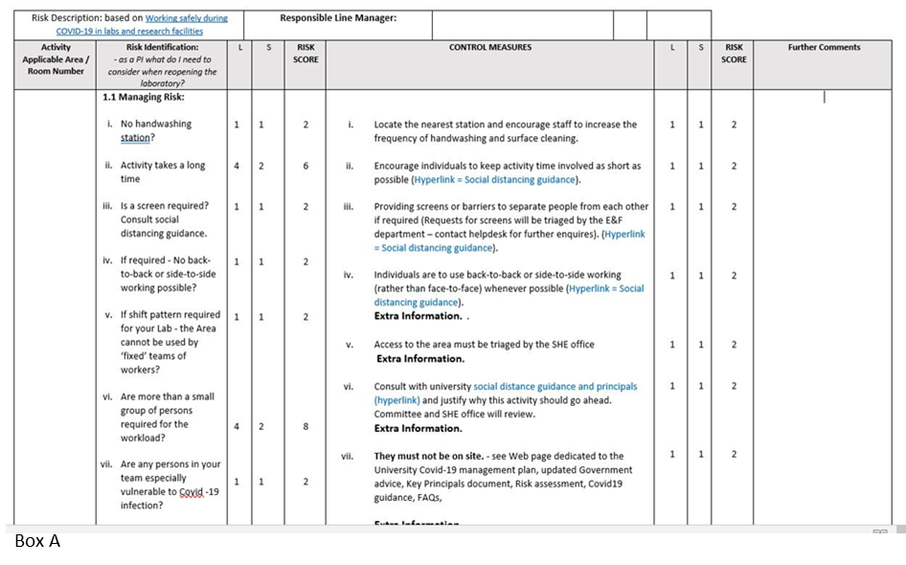
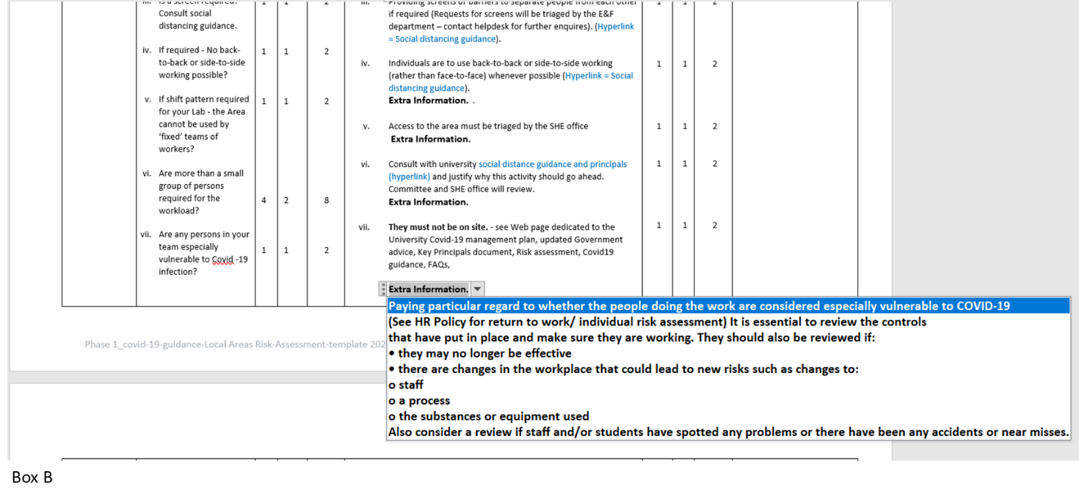

Trouble shooting:
- Selected a line in the extra information box that now displays in the control measures – click the ‘undo’ button and it should return to display the text ‘extra information’.
- Useful
Key Documents:
- Key Principles document
- Social distancing guidance
- HR guidance
- Working safely during COVID-19 in labs and research facilities

