DSE Assessment for home working- Advice for Line Managers
The University will support ‘reasonable adjustment’ in response to issues.
Guidance on DSE can be found here https://www.sgul.ac.uk/about/our-professional-services/safety-health-and-environment/workplace-health-safety-and-welfare/workplace-health-and-safety-general/display-screen-equipment-use-of-computers
Line managers should discuss issues with staff to find solutions and/or work with the Safety Health and Environment team (health@sgul.ac.uk) on other adjustments.
Staff should be encouraged to take frequent breaks and move around as often as required.
Staff should be encouraged try different chair/table combinations (if possible) and the location of the chair in relationship to the desk/table.
Computer equipment has already been provided to key staff. Screens, keyboards, mouse etc. are available. IT purchases should follow the existing process - a request via itav@sgul.ac.uk. The requestor should include their preferred delivery address, all purchases must be approved by the line manager and be funded from existing budgets.
If staff and their Line Manager are able to find and agree alternative solutions to resolve concerns identified from the DSE assessment, the Line Manager should use the ‘Resolve the issue’ function as confirmation. The ‘Add Comment’ function should be used for those concerns that are not resolved. Please provide as much detail as possible to help the SHE Office with assistance in addressing those concerns.If an adjustable/special chair is required at home two routes of action are now available.
1. If staff already have an adjustable chair at work, they can arrange to collect it from the University. This can be organised by Trevor McIlree, Site Services Manager by emailing tmcilree@sgul.ac.uk who will arrange for site services team to collect the chair from the office. Individuals can then organise with site services a date and time for collection by car from outside the Goods In entrance at the bottom of the ramp from the perimeter road of St George’s (see attached map) . We recommend this approach if possible as the chair has already been fitted to the user although it may need to be adjusted for the height of the desk.

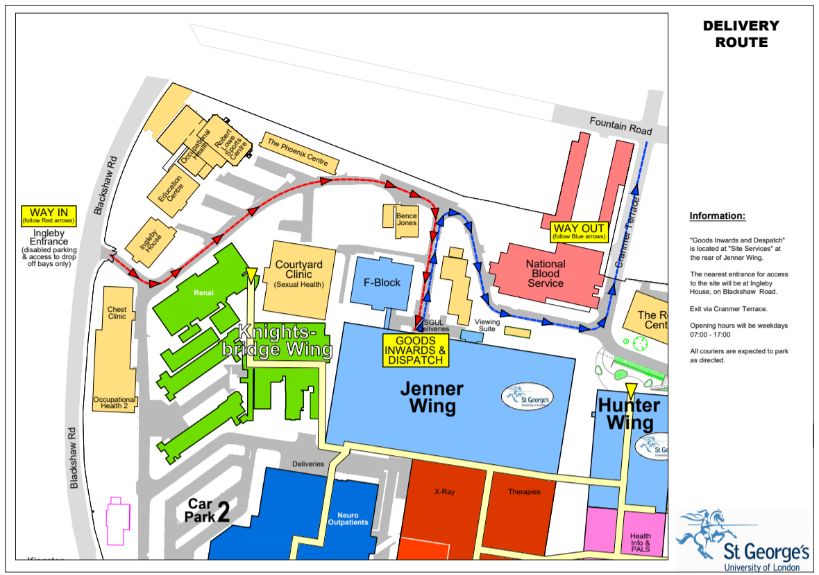

2. Alternatively, chairs can be ordered from an approved supplier using the normal purchasing process via agresso. The Line Manager/Budget holder will need to approve a budget code and the individual will need to provide their home address for delivery (we recommend contacting suppliers first to ensure that they deliver to the required area contact.banner@BannerUK.com or on 0843 538 3311). Equipment will only be delivered to the door and not installed.
https://www.easyflip.co.uk/Banner_Furniture/?__hssc=101696798.1.1585672791392&__hstc=101696798.cdf4d8f7e1e436365fd3fb9883b5b6c2.1585672791391.1585672791391.1585672791391.1&__hsfp=141168424&hsCtaTracking=0f07125e-7538-4791-aff4-acf91a55f99a%7C6528a160-b5e0-4c42-883b-c783ec9cd19c
Special chairs need setting up/fitting. DSE guidance for setting up your workstation/chair has been provided under Guidance for Staff. Measurements of the individual need to be taken before ordering (a family member could do this). The SHE Office can provide help and guidance on measurement and chair types (health@sgul.ac.uk). The normal lead time for chairs to be produced is 3–4 weeks. It may be longer in the current circumstances.
We currently cannot organise collection or supply of sit/stand desks to the home.
Budget Holders support the cost of supplying computer and specialist office equipment. Starting price for chairs is ~£200. More specialist chairs can cost between £500 - £600.
If a change in working practice to accommodate issues is required, this should be discussed with HR.
It is essential that Line Managers keep accurate records of chairs that have been either purchased or transferred from SGUL premises, so they can be returned when staff are able to return to work on a business as usual basis.

