SGUL
Control Of Substances Hazardous to Health Risk Assessment v.1.9

Please do the following:

- Fill in the form electronically
- Inform the SHE office if you are using any of the following:
- have any group 2 or 3 biohazard ACDP agents
- have group 2, 3 or 4 organisms that are listed in the Specified Animal Pathogen Order
- have any microbiological organisms or toxins that may require secure storage – further information can be obtained from the SHE office

- Store on secure computer ( or shared drive)
- File a hardcopy ( with USER SIGNATURES) in a folder in the lab
- Review every 3 years or if protocol changes. Or in the event of an accident. or legislative change

Title of Method:

Insert Method Title Here

Date Assessed:
Assessment Date.

PI/ Line manager Signature:
Name and Signatures of those covered by this assessment:
Name | Student / Staff | Signature | Date that you start using the procedure

Implementation and Communication of the COSHH
Assessment

Name of Assessor: Enter Name Here.

Signature of Assessor:

Who is responsible for communicating this assessment to other staff: Enter Name Here.

Signature of person responsible for communicating this assessment to other staff:

Review of COSHH Assessment

Review date of assessment:

Date review of assessment carried out:

Name of COSHH assessment reviewer:

Signature of COSHH assessment reviewer:

The SHE office recommend that a COSHH form/risk assessment should be reviewed annually or at the most every 3 years. The decision about when to review, is dependent on the hazardous nature of the work or a change of substance / working practice during the procedure.

For the approved HSE code of practice and guidance for COSHH please see the following link:
http://www.hse.gov.uk/pubns/priced/l5.pdf

Brief Description of Method:
Insert Method Description Here

Individuals who might be at risk:
Insert List of at Risk Individuals Here

Summary Evaluation:
Users should delete relevant sections from the document if the answer is No in the summary evaluation.
All other sections should be completed. Page 1 & 2 must accompany COSHH at all times

Does the method involve? Must complete section number

Human Pathogens Yes ☐ No☐ 3, 17
Animal Pathogens Yes ☐ No☐ 4, 17
Blood work Yes ☐ No☐ 5, 17
Cell lines – animal or human Yes ☐ No☐ 6, 17
Toxic or Venom hazard Yes ☐ No☐ 7, 17
Pharmacologically active agent Yes ☐ No☐ 8, 17
Plant hazard Yes ☐ No☐ 9, 17
Human Tissue Yes ☐ No☐ 10, 17
Chemicals Yes ☐ No☐ 11, 12, 18
Chemicals - solvents Yes ☐ No☐ 12, 13, 18
Toxic gases Yes ☐ No☐ 11, 12, 18
Further Considerations/Clarifications Yes ☐ No☐ 19

Control of Substances Hazardous to Health Risk Assessment form

Name of Risk Assessor (please give full title): Enter Name Here.

Role of Risk Assessor: Enter Role Here.

Where will the work be carried out?

Institute: Select Institute From Drop Down

Room Number: Enter Room Number Here.

Location: Enter Location Here.

Research Group/PI: Enter Research Group/PI Here.

Section 1 Describe the Task

Describe in moderate detail what the work will involve, and any specialised equipment that will be used:

Start from the beginning of the procedure. Working through, consider the use of equipment, facilities, as well as chemicals. Use blue font colour.

Step 1:

Step 2:

Step 3: etc.

Section 2 Determine the hazards and the risks that the task
poses
(For information on this section refer to Part 2 of the COSHH Guidance).
Further information or assistance can be obtained from the Safety, Health and environment office on x0637 or e-mail COSHH Query

Look at the risks involved in the procedure you are undertaking.
Aim is to determine the level of risk posed to the individual undertaking the work or others working nearby.
(E.g., use of hazardous organisms and chemicals and their appropriate handling/disposal)
Use blue font colour. Please include CAS numbers if appropriate

Step 1:

Step 2:

Step 3: etc.

Section 3 - Biological Hazard Information
Organism name:
Insert Organism Name Here
Infection caused:
Insert Infection Caused Here
Source: Insert Source Here
e.g. blood, saliva or culture collection
Biohazard grouping: _____
Bacteria

☐ Virus ☐ In vivo work
☐ Fungi ☐ Generate Aerosols

☐ Parasite ☐ High Titres

Route of Potential Exposure(s):
(Inhalation, skin, eyes, ingestion or needlestick)

Insert Route Here

Human Pathogens infectious agents including Viruses, Bacteria, Parasites and Fungi
please use appendix 1 to add extra organisms into this section
Please copy (ctrl c) and paste (ctrl v) the whole appendix 1 into the area above section 4
Organism name: Insert Organism Name Here
Infection caused: Insert Infection Caused Here
Source: Insert Source Here
e.g. blood, saliva or culture collection
Biohazard grouping: _____
☐ Virus ☐ In vivo work ☐ Bacteria ☐ Fungi☐ Generate Aerosols ☐ Parasite ☐ High Titres
At Risk Groups Insert brief information here
Route of Potential Exposure(s):
(Inhalation, skin, eyes, ingestion or needlestick)

Insert Route Here
Organism name: Insert Organism Name Here
Infection caused: Insert Infection Caused Here
Source: Insert Source Here
e.g. blood, saliva or culture collection
Biohazard grouping: _____
☐ Virus ☐ In vivo work ☐ Bacteria ☐ Fungi☐ Generate Aerosols ☐ Parasite ☐ High Titres
At Risk Groups Insert brief information here
Route of Potential Exposure(s):
(Inhalation, skin, eyes, ingestion or needlestick)

Insert Route Here

Section 4 - Biological Hazard Information
Animal Pathogens please use appendix 2 to add extra organisms into this section
Please copy (ctrl c) and paste (ctrl v) the whole appendix 2 into the area above section 5

Will work be undertaken with organisms that are listed on Schedule 1 of the Specified Animal Pathogen Order (SAPO)

Yes ☐ No ☐

Organism name and the infection that it causes.
Organism name: Insert Organism Name Here
Infection caused: Insert Infection Caused Here
Source: Insert Source Here
e.g. blood, saliva or culture collection
Biohazard grouping: _____
☐ Virus ☐ Bacteria ☐ Fungi ☐ Risk to Humans ☐ Parasite
At Risk Groups Insert brief information here

Route of Potential Exposure(s):
(Inhalation, skin, eyes, ingestion or needlestick)

Insert Route Here
Organism name: Insert Organism Name Here
Infection caused: Insert Infection Caused Here
Source: Insert Source Here
e.g. blood, saliva or culture collection
Biohazard grouping: _____
☐ Virus ☐ Bacteria ☐ Fungi ☐ Risk to Humans ☐ Parasite
At Risk Groups Insert brief information here

Route of Potential Exposure(s):
(Inhalation, skin, eyes, ingestion or needlestick)

Insert Route Here

Section 5 - Biological Hazard Information

Blood Work

- Will unscreened blood be used? Yes ☐ No ☐
if no, proceed to question 5

- Is it obtained from donors within the laboratory? Yes ☐ No ☐
If yes , Ethics approval must be sought from St Georges Research Ethics Committee

- Has the individual lab donor recently had a full blood count? Yes ☐ No ☐

- Is there a suitable area to bleed the donor? Yes ☐ No ☐

- Will blood be obtained from the Blood Service? Yes ☐ No ☐

Section 6 - Biological Hazard Information

Cell Lines

- Will unscreened primary human cell lines be used? Yes ☐ No ☐
if yes, please list below:

- Will primary cell lines be used? Yes ☐ No ☐
if yes, please list below:

- Will secondary cell lines be used? Yes ☐ No ☐
if yes, please list below:

- Could the cell lines possibly be of risk to humans? Yes ☐ No ☐

- Will they be obtained as gifts from another laboratory? Yes ☐ No ☐

If yes, please state the name and address of the supplying laboratory
Use blue font colour.

- Will the cells be obtained from a type collections source or a company
e.g. ATCC , ECACC Yes ☐ No ☐
If yes, please state the name and address of the supplying collection or company. Use red font colour.

- Have the celIs been transformed or transfected with DNA / RNA? Yes ☐ No ☐
if yes, please describe.
Please give the name of the plasmid / virus, the method used and any other info. i.e. is the transfection stable or unstable:

- Have the cells been fully characterised? Yes ☐ No ☐

Section 7 - Biological Hazard Information
Toxin or Venom Hazard Information

- Will Toxins or Venoms be used? Yes ☐ No ☐
if yes, please describe.

Use blue font colour.
Please give the name of the toxin / venom and its effects on humans:

Section 8 - Biological Hazard Information

Pharmacologically active agents Hazard Information

- Will pharmacologically active agents be used? Yes ☐ No ☐
if yes, please describe.
Use blue font colour.
Please give the name of the agent and its effects on humans:

Section 9 - Biological Hazard Information
Plant Hazard Information

- Will the plant pose a hazard to humans? Yes ☐ No ☐

- Does the plant produce Toxins? Yes ☐ No ☐

- Does the plant produce Allergens? Yes ☐ No ☐

- Does the plant produce pharmacologically active agents? Yes ☐ No ☐

If the answer is yes to any of the above questions please name the plant and describe the relevant effects.
Use blue font colour.

Section 10 - Biological Hazard Information

Human Tissue/ Samples
- Will this work involve obtaining / use of human tissue? Yes ☐ No ☐

- Will this work involve obtaining / use of human samples that contain cells? Yes ☐ No ☐

- Has the HTA designated individual been informed about the tissue/samples? Yes ☐ No ☐

- Are the tissue/samples stored under the HTA licence? Yes ☐ No ☐

Section 11 - Chemical Hazard Information

This section is designed for you to:
- consider all the chemicals you will use in your experimental method
- Consider the consequences of exposure to the chemicals.
- Be aware of the type of chemical hazard and put measures in place to avoid it.
Advice - Chemical segregation must be considered, with flammables not being stored next to oxidising agents or strong acids
Further, information on the hazard(s) posed by the chemical(s) that may be used will be available from the Safety Data Sheet (SDS) supplied with the chemical at the time of purchase.
Workplace Exposure Limits can be checked via EH40/2005.

Name the chemicals that are a hazard:
please use appendix 3 to add extra chemicals into this section
Please copy (ctrl c) and paste (ctrl v) the whole appendix 3 into the area above section 11

Name: Insert Name Here
Physical State: Choose State
W.E.L: Insert W.E.L Here
At Risk Groups Insert brief information here
Chemical flashpoint: <50°C Yes ☐ No ☐
Hazard:
Corrosive 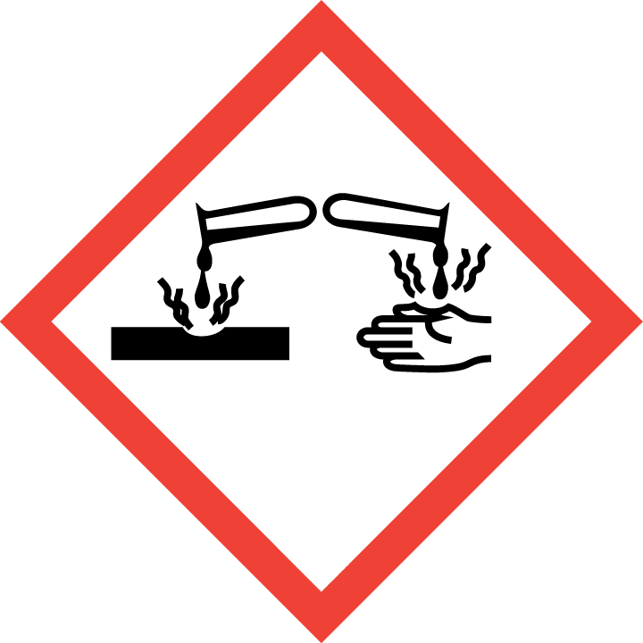☐ Acute toxicity 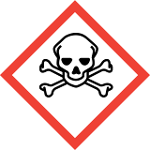☐ Inhalation 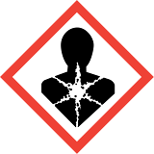☐
Flammable 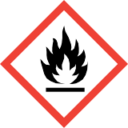☐ Irritant ☐ Environmental 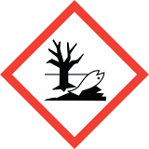☐
Oxidising 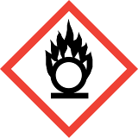☐ Compressed gas ☐ Explosive 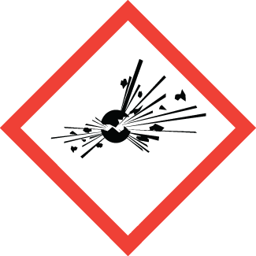☐
Route of exposure:
Insert Route Here

Name: Insert Name Here
Physical State: Choose State
W.E.L: Insert W.E.L Here
At Risk Groups Insert brief information here
Chemical flashpoint: <50°C Yes ☐ No ☐
Hazard:
Corrosive ☐ Acute toxicity ☐ Inhalation ☐
Flammable ☐ Irritant ☐ Environmental ☐
Oxidising ☐ Compressed gas ☐ Explosive ☐
Route of exposure:
Insert Route Here

Name: Insert Name Here
Physical State: Choose State
W.E.L: Insert W.E.L Here
At Risk Groups Insert brief information here
Chemical flashpoint: <50°C Yes ☐ No ☐
Hazard:
Corrosive ☐ Acute toxicity ☐ Inhalation ☐
Flammable ☐ Irritant ☐ Environmental ☐
Oxidising ☐ Compressed gas ☐ Explosive ☐
Route of exposure:
Insert Route Here

Name: Insert Name Here
Physical State: Choose State
W.E.L: Insert W.E.L Here
At Risk Groups Insert brief information here
Chemical flashpoint: <50°C Yes ☐ No ☐
Hazard:
Corrosive ☐ Acute toxicity ☐ Inhalation ☐
Flammable ☐ Irritant ☐ Environmental ☐
Oxidising ☐ Compressed gas ☐ Explosive ☐
Route of exposure:
Insert Route Here

Section 12 – Chemical Hazard Information
Chemical Workplace Exposure Limits (WEL)

Do any of the the chemicals used have a work exposure limit assigned? This can be checked via EH40/2005.
If WEL applies, then extra consideration must be given to the amounts / volumes of material individuals will be exposed to.
Short-term exposure limits (STELs) are set to help prevent short term effects e.g.eye irritation, which may occur following exposure for a few minutes.
Long-term exposure limits (LTELs) are set to help prevent some illnesses caused by exposure to hazardous substances in the workplace (occupational diseases) that may not appear until a long time after the first exposure.
Use blue font colour.
Please name the applicable chemicals below, indicating whether it is long-term / short-term exposure limit and describe what measures are being taken to lower the levels of exposure to a minimum:

Chemical Flash Point Information

If any of the chemicals used during procedure have a flash point below 50ºC, then extra consideration must be given to the amounts of material used and the potential fire hazard, especially in labs where there are naked flames or equipment that is not spark free.
Globally Harmonized System of Classification definitions:
≥ 50 ºC Combustible (warning)

25 - 50 ºC Flammable (warning)
Further, if the solvents used have low flash points (0-25ºC) the proximity of flames and heat souces must be considered!

0 - 25 ºC Highly flammable (danger)

≤ 0 ºC Extremely flammable (danger)

Use blue font colour.
Please name the applicable chemicals below, and indicate what measures are being taken to avoid ignition:

Section 13 Chemical Hazard Information
Storage of Solvents

It is recommened that no more than 20L of solvents are stored in labs and must be in an appropriate metal solvent cabinet!

- Will solvents or solvent containing solutions need to be stored at or below 4ºC?
Yes ☐ No ☐

- If yes, is the fridge / freezer spark-proof or spark free?
Yes ☐ No ☐

If your response to question 2 is no, then do not use this applicance, find an alternative appliance that is spark free.

Use of open / naked flames / hot equipment

- Will open / naked flames be used during the protocol close to solvents or in the same room?.
Yes ☐ No ☐

- Will hot equipment be used during the protocol close to solvents. Yes ☐ No ☐

If the answer to question 1 or 2 is yes, the please avoid and/or seek advice from Colin Sandiford (SHE office).

14a- Personal Protective Equipment
Tick if the below are required :

Clothing

Lab coat: Yes ☐ No ☐ Not Applicable ☐

Howie coat: Yes ☐ No ☐ Not Applicable ☐

Chemical resistant clothing: Yes ☐ No ☐ Not Applicable ☐

14b-Respiratory Protection

- Respiratory Protection required? Yes ☐ No ☐
if no, move on to hand protection section.

- Respiratory Protection using chemical filters required? Yes ☐ No ☐

- Powered Respiratory Protection required? Yes ☐ No ☐

- If 2 or 3 apply, has the individual been face fitted for equipment and trained in its use?
Yes ☐ No ☐

If answer yes, please describe below: Use blue font colour.
please specify:

14c -Hand Protection

- Gloves required? Yes ☐ No ☐

- Special chemical resistant gloves required? Yes ☐ No ☐

If answer yes, please describe below: Use blue font colour.

please specify:

14d - Eye Protection

- Eye Protection required? Yes ☐ No ☐
If yes, answer questions 2 and 3.

- Safety Glasses: Yes ☐ No ☐

- Full face shield: Yes ☐ No ☐ Not Applicable ☐

14e - Other Protection

If any other protection is required, please give details here: Use blue font colour.

Section 15 - Control Measures

Use this section to describe any procedural control measures or precautions that are currently in place e.g. extraction, ventilation, training, or supervision. Include special measures for vulnerable groups, such as disabled people and pregnant workers.

Use blue font colour.
please specify:

Section 16 - Indicate the level of residual risk the task poses, after use of
Control Measures

Explain the reason for your decision (Refer to part 3 of the guidance. Risk could be Low / Medium / High)

Indicate the Level of Risk

Where work presents a medium or high risk of harm, additional safety measures must be put in place.

. Use blue font colour.
If additional safety measures are taken, please state below:
please specify:

Section 17 -Waste Disposal Procedures –Biological Hazard

Biological
What stream of waste will be used:

☐ ☐ ☐ ☐ ☐ ☐ ☐

Autoclave Sharps Bin Cytotoxic Bin Pharmacy Yellow Bag Orange Bag Offensive
Waste
Use blue font colour.
Other? Please give brief description:

Spill / Emergency Procedures

Have procedures been produced to deal with spills of biological agents during transfer of the organisms, during procedures and during transfer of waste material including power failure or equipment failure?

Yes ☐ No ☐

If yes please detail the procedure below or append it to this assessment

Use blue font colour.

Are biological spill kits /disinfectants readily available and do the workers know where they are located?

Yes ☐ No ☐

Have procedures been produced to deal with contamination by / or inhalation of biological agents during transfer of the organisms, during procedures and during transfer of waste material?

Yes ☐ No ☐

If yes please detail the procedure below or append it to this assessment
Use blue font colour.

Have procedures been produced to deal with entrance of biological agents into open wounds materializing during transfer of the organisms, during procedures and during transfer of waste material?

Yes ☐ No ☐

If yes please detail the procedure below or append it to this assessment

Use blue font colour.

Section 18- Waste Disposal Procedures –Chemical Hazard

Chemical – please describe the kind of waste generated

☐ ☐ ☐ ☐ ☐ ☐ ☐

Halogenated Non-halogenated Flammable Corrosive Oxidising Powder Solid
Liquid Waste Liquid Waste Liquid Liquid agent

☐ ☐

Controlled Drug Drug Precursor
Other? Please give brief description: Use blue font colour.

Spill / Emergency Procedures

Have procedures been produced to deal with spills of chemicals during procedures and during transfer of waste including power failure or equipment failure?
Yes ☐ No ☐

If yes please detail the procedure below or append it to this assessment
Use blue font colour.

Are chemical spill kits / spill granules readily available and do the workers know where they are located?
Yes ☐ No ☐

Have procedures been produced to deal with contamination by / or inhalation of chemicals during procedures and during transfer of waste?

Yes ☐ No ☐

If yes please detail the procedure below or append it to this assessment

Use blue font colour.

Have procedures been produced to deal with entrance of chemicals into open wounds during procedures and during transfer of waste?

Yes ☐ No ☐

If yes please detail the procedure below or append it to this assessment Use blue font colour.

