Mandatory Training Guide
All mandatory training needs to be completed within 2 months of joining the University and then reviewed again on a frequent basis. Please find below a list of the Mandatory Training all staff need to complete, how often it needs to be completed and an estimated amount of time each course takes to do:
Mandatory Training | Method of Delivery | Department Responsible | Frequency | Duration
Display Screen Equipment (DSE) e-learning | e-Learning | SHE Office | Every 3 Years | 30 mins
Home Display Screen Risk Assessment | e-Learning | SHE Office | Annually | 10 mins
Office Display Screen Risk Assessment | e-Learning | SHE Office | Annually | 10 mins
Fire Safety | e-Learning | SHE Office | Annually | 30 mins
Information Security Essentials* | e-Learning | Information Services | Annually / Every 2 Years | 45 mins
Data Protection Briefing* | e-Learning | Information Services | Annually / Every 2 Years | 50 mins
General Health, Safety and Environmental Awareness | e-Learning | SHE Office | Every 3 Years | 30 mins
Prevent Duty Training | e-Learning | Information Services | Every 2 Years | 45 mins
Manual Handling | e-Learning | SHE Office | Every 3 Years | 30 mins
Stress Management | e-Learning | SHE Office | Every 3 Years | 30 mins
Personal Safety | e-Learning | SHE Office | Every 3 Years | 30 mins
Diversity in the Workplace | e-Learning | HR (Diversity & Inclusion) | Every 3 Years | 60 mins
Let’s Talk About Race in the Workplace | e-Learning | HR (Diversity & Inclusion) | Every 3 Years | 30 mins
Introduction to Digital Accessibility | e-Learning | Information Services | Every 3 years | 60 mins
Action Counter Terrorism | e-Learning | Information Services | Every 3 years | 45 mins
Hidden Disabilities Sunflower | e-Learning | HR (Diversity & Inclusion) | Every 3 years | 60 mins
Basic Cyber Hygiene | e-Learning | Information Services | Every 3 years | 30 mins
Recruitment and Selection Interviewing | Workshops | HR (Business Partners) | Every 3 years | 120 mins
PGCert HBE | Workshops | Academic Staff | Commence within probation | IMBE

* Your MyTraining account will reflect the frequency that you need to complete the Information Security Essentials and Data Protection Briefing courses as it depends on your role. If you are involved in the submission for the Data Security & Protection Toolkit, you have to complete these courses annually. For everyone else the requirement is every 2 years.
The Data Security & Protection Toolkit applies to those who handle NHS patient data, which will primarily be research staff and staff that support these research activities.
More information can be found on the Information Governance Awareness Training page here: Information Governance Training (sgul.ac.uk)

2. Mandatory Training Policy
The Mandatory Training Policy can be found on the SGUL website here
Line Managers must ensure they are satisfied that all their direct reports’ courses are up to date to sign off the PDR each year.
To check your teams progress and status, MyTraining has a section for line managers to check the status of their direct reports completion. Please see section 6. Checking Team Completion rates for Managers below for instructions on how to do this.
3. Accessing MyTraining:
To access MyTraining, click on the following link: https://mytraining.sgul.ac.uk
Alternatively, click on MyWorkplace > Learning > MyTraining
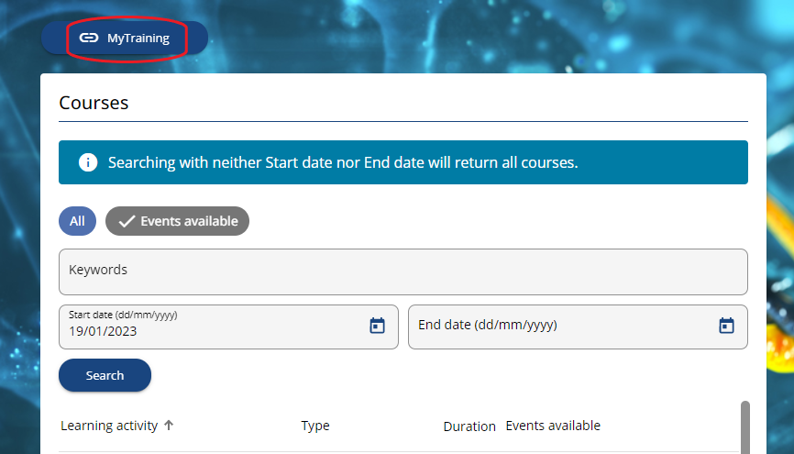
You will be presented with a Sign In window. Click SIGN IN WITH YOUR SGUL ACCOUNT
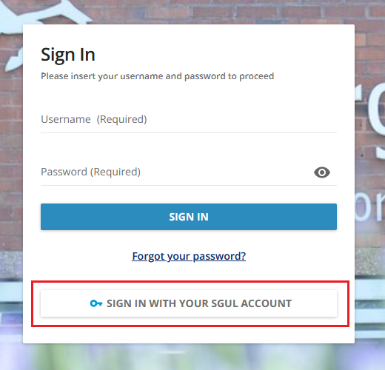
Your Learner Dashboard will be displayed. Click on each course to start.
Note: You will be able to see at a glance which courses still need to be completed. The top right corner of each thumbnail will show the status of the course:
- Not Started
- In Progress
- Completed
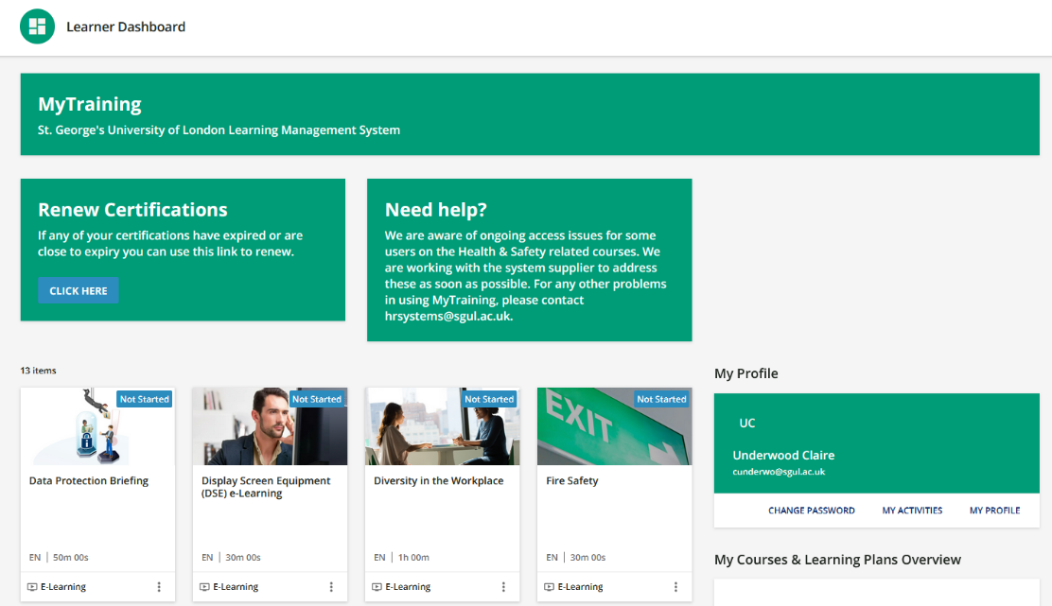
If you are unable to see a particular course, click on View All at the bottom of the screen.
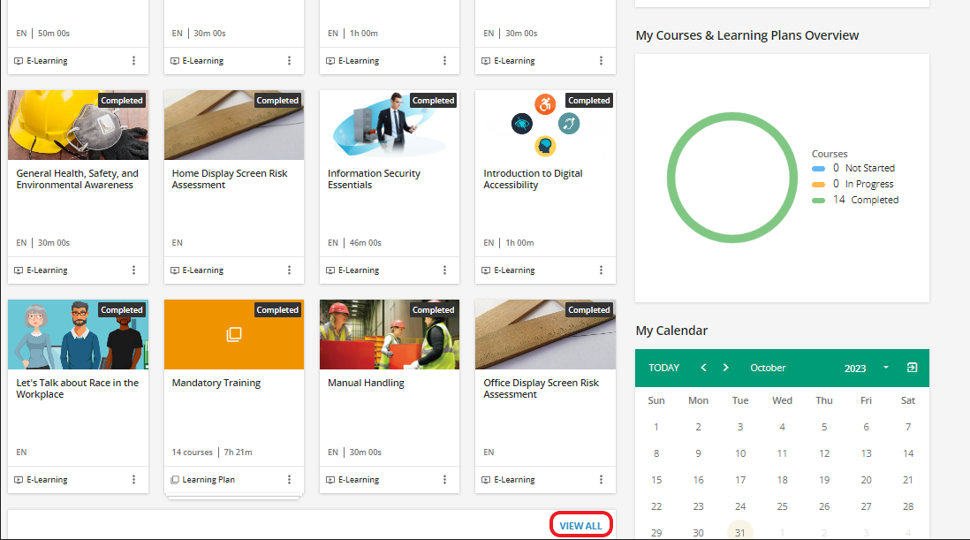
Note: For users of the previous systems prior to 1st August 2022 when the new MyTraining platform was launched, the date you last completed the course will not have been transferred over. As you build up your completed courses over time, you will be sent reminders and your Calendar will display when the course is needed to be retaken.
4. Health and Safety Training
All staff are required to complete health and safety training as part of their role, with most e-Learning courses needing to be retaken on an annual basis. Please go to SHE training and/or the Mandatory Training Policy to find out about the online training for you need to complete. You will also find details of other health and safety workshops to attend.
You will need to complete 2 x Display Screen Equipment online courses if you work on a hybrid basis. One for working in the office, one for working from home. If you hot desk in the office, most desks should be set up similarly so you do not need to do a DSE Risk Assessment for every desk you use. Arrangements will be made for anyone in need of a specific set up or equipment.
The DSE Risk Assessments will be locked. You will need to ensure that you complete the Display Screen Equipment (DSE) e-Learning first to unlock the risk assessments for Office and Home:
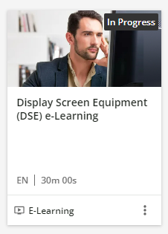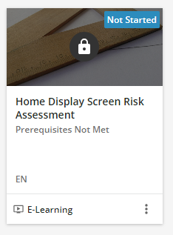
Please contact the SHE Office (health@sgul.ac.uk) if you have any questions about safety, health and environment training.
5. Certificates of Completion:
If you need a copy of a certificate to confirm you have completed your mandatory training, go to the Learner Dashboard > My Activities > Courses:
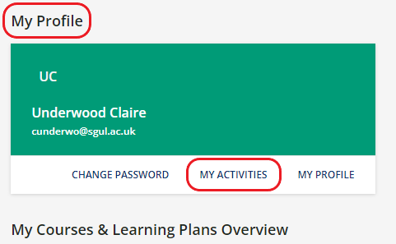 | 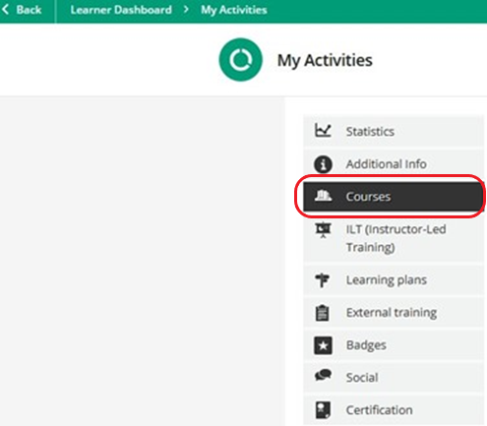
You will see a rosette that indicates a certificate is available to download on the right of the screen:
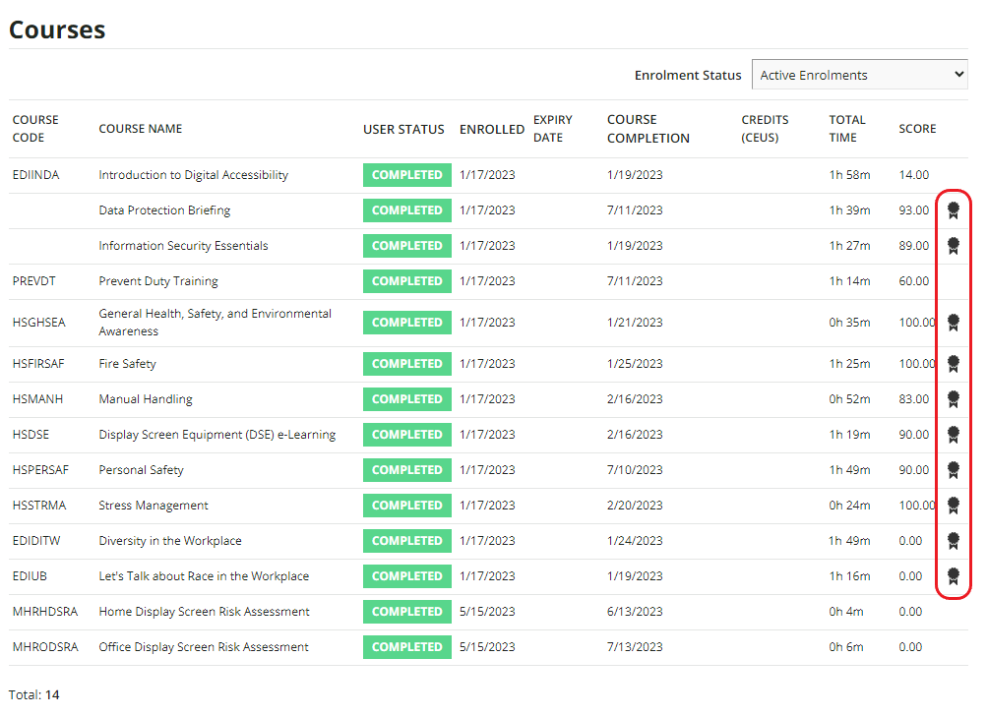
Please note that this is not the case for all mandatory modules.
There are currently no certificates for the Introduction to Digital Accessibility module. If you require confirmation that you have completed the training and passed the test, Pui Chan is able to confirm - please contact pchan@sgul.ac.uk
You will only be able to download the certificate for the Prevent training module at the time of completing the course. Unfortunately, you will not be able to go back in and download it again at a later date as the certificate is built into the module rather than the MyTraining system.
The Home and Office DSE Risk Assessments will send an email to your Line manager indicating if any items were flagged and need to be addressed.
6. Checking Team Completion rates for Managers
Line managers are able to view their direct report’s completion rates of mandatory training. To do this:
From the Learner Dashboard, click the User Menu in the top right corner: | 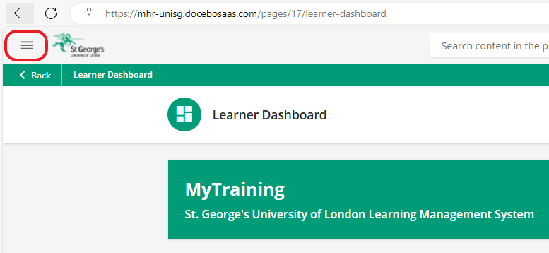
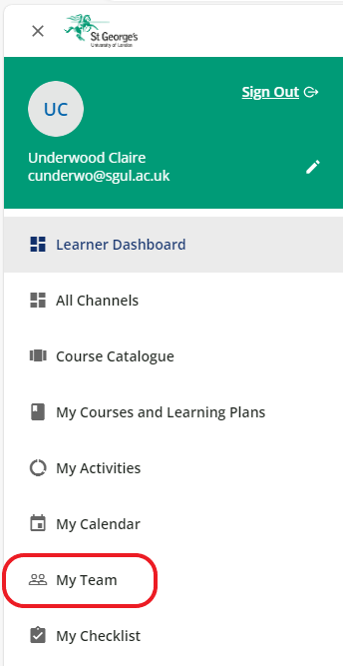 | From the drop down menu, select My Team
Click the Actions button (3 dots) at the bottom and then select User Summary Report: | 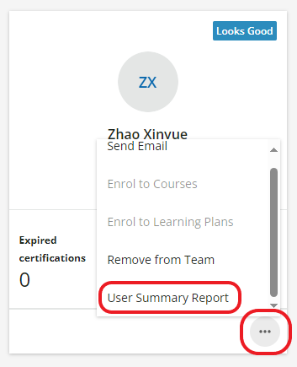
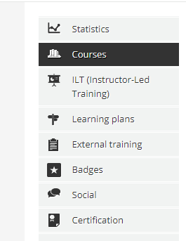 | Click Courses in the left hand menu
The User Status column will show which courses have been completed, which are in progress and which ones have not yet been started: | 