|  |
| --- |
|  |
|  |
| December 2022 Newsletter |
|  |

## 

## **WELCOME TO NEW STAFF**

INSTITUTE FOR

INFECTION &

IMMUNITY

|  |  |  |  |
| --- | --- | --- | --- |
| |  | | --- | |  | |  | | **TRAVELLING ON BUSINESS**  Record all business travel in [MyWorkplace](https://myworkplace.sgul.ac.uk/) under ‘other absence’ to ensure you are covered on your business trip AND you must complete the  [travel certificate](https://www.sgul.ac.uk/about/our-professional-services/finance/documents/Travelcertificate-v3.xlsx)  for each travel occasion and [email the completed form](mailto:travcert@sgul.ac.uk) prior to the start date | |
|  |

Welcome to the following staff who joined us recently:

Dr Melissa Chowdhury, Clinical Research Fellow for Kirsty Le Doare

Dr Tatiana Bovill Rose, Clinical Research Fellow for Catherine Cosgrove

Dr Phoebe Allebone-Salt, Clinical Research Fellow for Tihana Bicanic

Michael Thorn, Technical Consultant & Project Manager for Mike Sharland

Dr Natasha Thorn, Clinical Research Fellow for Paul Heath

Jarvey Torres-Garzon, Research Development Officer for Nidhi Sofat

Dr Mary Kyohere, Clinical Trial Manager for Simon Drysdale

Peter Sequenza, Clinical Trials Assistant for Simon Drysdale

Farah Seedat, Postdoctoral Research Associate for Sally Hargreaves

Cemal Cagil Kocana, Research Scientist for Paul Heath

Dr Claire Sharkey, Clinical Research Fellow for Paul Heath

William Cuningham, Research Data Analyst for Mike Sharland

The all-in-one information tool for new and existing research staff is available via the link [Arrival and Survival Guide for Academic and Research Staff.](https://www.sgul.ac.uk/research/research-operations/documents/Arrival-Survival-Guide-Dec-21.pdf) The fully searchable guide has lots of guidance for existing staff, therefore do take some time to read through the pages relevant to you.

**Institute CHRISTMAS PARTY THursday, 15th December, 4.30pm**

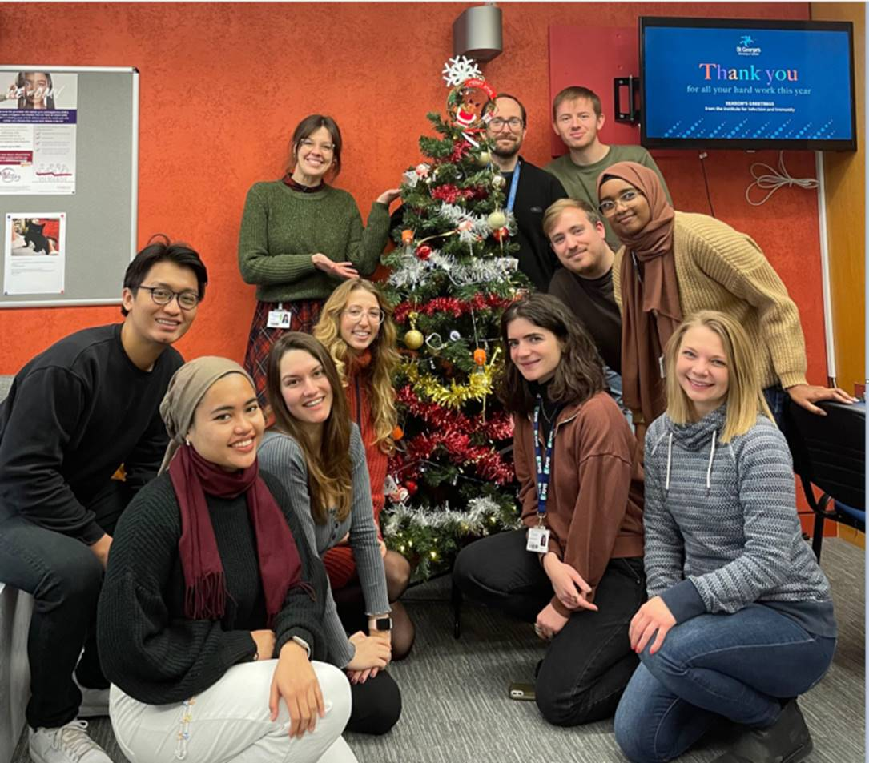

Thanks to our staff, PhD students and medical students for setting up the II&I Christmas tree in the reception area.

Join us for the II&I Christmas party on Thursday, 15th December at 4.30pm in the reception area for a festive buffet and drinks!

**ROLLING 6 monthly Lab SELF INSPECTIONS**

A reminder to all PIs that we are soon due the rolling lab self-inspections in the New Year. Please ensure you keep up to date and send your updated forms to the Institute Manager [IIinstitutemanager@sgul.ac.uk](mailto:IIinstitutemanager@sgul.ac.uk)

Please note that it is the responsibility of the PI/their group to make sure all actions have been completed. Research Institute Managers are required to keep a record of all completed inspections as we need to report back to the SHE Office on non-compliance in March and September each year.

Note the new form that has been in place for some months:

* + [A laboratory inspection checklist](https://www.sgul.ac.uk/about/our-professional-services/safety-health-and-environment/documents/staff-only/Lab-inspection-checklist-February-2019-v2.xlsm) (Excel)

**JRES CONTACTS**

**Research funding officers - Pre-award**

Oliver Palmer [opalmer@sgul.ac.uk -](mailto:opalmer@sgul.ac.uk%20-) Institute for Infection & Immunity

Adeyemi Adebiyi [adeadebi@sgul.ac.uk -](mailto:adeadebi@sgul.ac.uk%20-) Institute of Molecular & Clinical Sciences, Population Health Research Institute, and Institute of Medical & Biomedical Education.

Please contact Oliver or Adeyemi for support with grant applications and new grant awards, for both St George’s University and St George’s NHS Trust.

**Research funding officers - Post award**

Samiat Balogun [sbalogun@sgul.ac.uk -](mailto:sbalogun@sgul.ac.uk%20-) Institute for Infection & Immunity

Tej Daswani  [tdaswani@sgul.ac.uk-](mailto:tdaswani@sgul.ac.uk-) Institute of Molecular & Clinical Sciences, Population Health Research Institute, and Institute of Medical & Biomedical Education.

Jane Boland [jboland@sgul.ac.uk](mailto:jboland@sgul.ac.uk) remains the contact for all EU and EDCTP pre and post award queries.

Please contact Samiat or Tej for support with the post award management for St George’s University held grants. A separate team in JRES supports post award for St George’s NHS Trust [researchservices@stgeorges.nhs.uk](mailto:researchservices@stgeorges.nhs.uk).

We will also continue to use our shared inbox [research@sgul.ac.uK](mailto:research@sgul.ac.uK) which is monitored daily to ensure cross cover between the team during periods of absence.

*Louise Phillips, Head of Research Funding*

**PULSE SURVEY**

**Have your say - Pulse survey open until 21 December**

St George’s is committed to gathering your feedback and working together to create a positive employee experience.  As a listening organisation, one of the ways in which we do this is through our staff surveys, both full surveys and pulse surveys, which provide us with information on what we are doing well and what we need to do to improve.

Staff will have received a personalised email from People Insight inviting them to take part in the Pulse Survey on 1 December 2022 and follow up reminders if they haven’t completed it. The survey takes 10 minutes to complete and is available until **midnight on 21 December 2022.**Don’t miss your chance to have your say!

**Updated Costing Table**

The staff costing table has been updated for the August 2022 pay rise for SGUL and KU TUPE staff. To note that this table is only for information and actual costings for grants should be obtained via JRES.

The salary costing table is available on the II&I Information for Staff webpage which can be accessed via this link:

<https://www.sgul.ac.uk/about/our-institutes/infection-and-immunity/information-for-staff>

## **EVENTS**

* The [Institute for Infection & Immunity seminars](https://www.sgul.ac.uk/about/our-institutes/infection-and-immunity/events/seminars) are held every Wednesday, 1-2pm. Details are e-mailed out on a regular basis. They will resume on the 11th January 2023
* [The University Seminar programme](https://www.sgul.ac.uk/for-staff/news-and-projects/university-seminar-programme) is held on the fourth Thursday of the month, 1-2 pm. Two speakers each give talks of 20-25 mins with time for questions. Details are e-mailed out on a regular basis.

## **Additional USEFUL information**

* **Institute Staff Development Funding:** Funding is available for institute staff and PhD students to attend training courses and conferences. Application form and guidance on conditions and eligibility can be accessed via the weblink:

<https://www.sgul.ac.uk/about/our-institutes/infection-and-immunity/information-for-staff>

* All **mandatory training** now takes place in MyWorkplace, which can be accessed through the learning tab and the My training icon on the top left. Any problems contact hrsystems@sgul.ac.uk
* **Training on waste disposal:** The Safety, Health and Environment (SHE) office, deliver a monthly session on the various types of waste disposal. The session is open to staff and students and run via MS Teams. For further information and bookings contact Colin Sandiford ([**csandifo@sgul.ac.uk**](mailto:csandifo@sgul.ac.uk)) or Louise Lincoln ([**llincoln@sgul.ac.uk**](mailto:llincoln@sgul.ac.uk)).

* **Safety at work:** St George’s Estates and facilities helpdesk can be contacted for any maintenance, cleaning or waste issues that need addressing. Please email [estates@sgul.ac.uk](mailto:estates@sgul.ac.uk) or call extension: 1234, option 2.
* **Incident/Near-miss/accident reporting:** The online forms should be used to report accidents/incidents/ near misses/excessive lab temperatures at work. The link can be found here: [I](https://portal.sgul.ac.uk/she/Accident%20Reporting)[RIDDOX by SteSec ltd.](https://www.riddox.co.uk/form/MHZ1amdBUWQwWE1DU3FqckJkNVRFbExqMWMxY2lyWDVkaDViREc3VFBUaHpRcjdOdW0vaGNYcEZIVDNOb3cvTQ==)
* **First aid assistance procedure** – Dial 0208 725 0909 (security) and ask for a first aider, letting them know where you are and what the issue is. They will send the nearest first aider.
* **Reporting Data Breaches:** You can find the Data Incident Reporting Form [here](https://www.sgul.ac.uk/about/our-professional-services/information-services/information-governance/policies-and-procedures/information-technical-security).
* **IT Helpdesk:** The[IT Drop-In Helpdesk](http://georgesweekly.sgul.ac.uk/kwrhyq7nb5s/external?a=6&p=60613270&t=28568509) Service is open from 12pm to 2pm, Monday to Friday in room 0.49, Corridor 3, Jenner Wing for support with IT issues.
* St George’s library offer a host of IT training workshops to help staff develop their digital skills. Contact Fiona Graham [fgraham@sgul.ac.uk](mailto:fgraham@sgul.ac.uk) for more information.
* **SGUL Committee Meetings:** If you would like to find out more about what goes on at these meetings, you can read the minutes via “[Our Committee](https://www.sgul.ac.uk/about/our-professional-services/governance-legal-and-assurance-services/our-committees)” pages.

## **CENTRAL SERVICES UPDATES**

|  |
| --- |
| STARTERS AND LEAVERS  Starters:   * Priya Madhou, Head of Laboratory Services, Research Operations, 1 December 2022 * Brian Berry, Research and Enterprise Contracts Manager (Maternity Cover), JRES, 21 November 2022 * Gabriel Chin, Research and Enterprise Contracts Officer, JRES, November 2022 * Stanislavs Vasiljevs, Research and Enterprise Contracts Officer, JRES, November 2022 * Dimitra Mantzorou, Head of Zebrafish Unit, Research Operations, 31 October 2022 * Alice Eseola – IRF Imaging Manager, Research Operations, 1 November 2022 * James Bowden – HR Business Partner (Education), HR, 1 November 2022 * Megan Moody – Research Finance Business Partner, Finance, 2 November 2022 * Cheryl Watson – return from maternity leave; Head of Administration and Executive Officer to Vice Chancellor (R&E), Research Operations, 10 November 2022 * Charlotte Martin, Director of Governance, Legal and Assurance Services, 1 September 2022 * Noreen Kassem, Director of Education Operations, 19 September 2022   Leavers:   * Isabelle Crevel, Senior Technician, Research Operations, 29 November 2022 * Adam Hussain, Senior Planning Officer, Planning and Finance, 17 November 2022 * Billy Zeqiri – Research Finance Business Partner, Finance, 24 October 2022 * Caroline Davis – Director of ECRM, 31 October 2022 * Pamela Agar – Director of ECRM, 31 October 2022 * Jacqui Marks – maternity cover end, Head of Administration and Executive Officer to Vice Chancellor (R&E), Research Operations, 31 October 2022 * Adam Hussain – Senior Planning Officer, Finance, 15 November 2022 * Amy Fenton, Head of Student Recruitment, ERCM, September 2022 * Matt Allinson, Public Engagement Officer, Public Engagement, September 2022 * Johanna Willard, Research Funding Manager, JRES, October 2022 |

## **INSTITUTE STATUtORY REQUIREMENTS**

**Note: Individuals applying for institute funding will need to demonstrate they are compliant and up to date with requirements if they wish to apply for institute funding such as personal staff development funds.**

**Exceptions would be considered by the Director of the Institute.**

**All mandatory modules should now be completed in** [**MyWorkplace/Learning/My Training**](https://mhr-unisg.docebosaas.com/pages/17/learner-dashboard)

|  |  |  |
| --- | --- | --- |
| **Statutory Requirement** | **Frequency** | **Indicate you are up to date and include year of completion** |
| Health & Safety –Biological Agents Form | Annual requirement  Queries to the [SHE Office](mailto:SHE%20Office%20%3chealth@sgul.ac.uk%3e) |  |
| Health & Safety –COSHH Forms | Annual review for Hazard 3 agents & 2 yrs for others  Queries to the [SHE Office](mailto:SHE%20Office%20%3chealth@sgul.ac.uk%3e) |  |
| Health & Safety – Fire Safety | Annually  If you cannot access site, contact the [SHE Office](mailto:SHE%20Office%20%3chealth@sgul.ac.uk%3e) |  |
| Health & Safety – Display Screen Assessment | Annually  [Health & Safety E-learning Platform](https://sgul.britsafelearning.com/login/index.php) |  |
| Display Screen Equipment e-Learning | Annually |  |
| General Health, Safety and Environmental Awareness | Every 2 years |  |
| Manual Handling | Every 3 years |  |
| Diversity in the Workplace | Every 3 years  Queries to [Liz Grand](mailto:Liz%20Grand%20%3clgrand@sgul.ac.uk%3e) |  |
| Unconscious Bias | Every 3 years  Queries to [Liz Grand](mailto:Liz%20Grand%20%3clgrand@sgul.ac.uk%3e) |  |
| Prevent Duty Training | Every 2 years  Queries to  [Elizabeth Okona-Mensah](mailto:Elizabeth%20Okona-Mensah%20%3ceokona-m@sgul.ac.uk%3e) |  |
| Information Security Essentials  (IG Toolkit) | Annually |  |
| Time Allocation Survey (TAS) | Annually  (Academic HEFCE funded staff /or do teaching) |  |
| ORCID Number | Only single registration required (Essential for PhD students & upwards or where relevant) |  |

If you have any item to add to the newsletter, please contact me, Melanie Monteiro.

Melanie Monteiro

Research Institute Manager

Institute for Infection & Immunity

[**https://www.sgul.ac.uk/about/our-institutes/infection-and-immunity/information-for-staff**](https://www.sgul.ac.uk/about/our-institutes/infection-and-immunity/information-for-staff)

**Institute Webpage**