File structures.
Producing and utilising a file structure can facilitate organising your records in a manner which supports efficient retrieval and management. Well managed records can assist with responding to subject access requests, Freedom of Information requests, by helping you easily locate the records requested. A thoughtful, considered file structure will also help you meet the requirements of St George’s records management policies by enabling you to identify and review time expired records. The file structure should reflect the needs of your Directorate or team. Remember to consider specific requirements your Directorate or team may have and seek feedback from users.
Below are general guidelines to consider when creating or reviewing your file structure. Alternatively, contact the Records Manager advice and assistance.

Guidelines:
- Start by identifying the main types of records your Directorate or team create and manage. This could be human resources, finance, project files, job jackets, or funding bids.
- Establish a hierarchy; you can begin by prioritising the record categories you identified in step 1 based on the records importance and frequency of use. Based on this information you can create a top-level folder for each major category, with subfolders within each major category to further organise the records. Any hierarchy should reflect the relationship between your records and support the navigation of the records. For example, your hierarchy could look like the following:
  - Publication – works regardless of format issued for distribution to university staff.
    - Drafting – activities undertaken to create the publication, including reports, plans, etc.
      - Draft copies of the publication including website development, drafts for comment.
- When establishing your hierarchy consider the user experience. You don’t want so many subfiles that users must click through multiple levels to find what they want. On the other hand, you don’t want to sacrifice the relationship between the records and a logical structure.
- Use descriptive file names and be consistent. Give folders names that clearly describe the content held within. Use clear and concise language that are meaningful to members of staff accessing the records. Be consistent in naming your folders and ensure that the directorate or teams naming convention are applied consistently throughout the file structure.
  - Avoid using abbreviations unless everybody who accesses the records knows what it means.
  - Avoid using an individual staff members name as this does not adequately describe what is in the folders.
- Depending on the nature of your records you can choose to order them chronologically, alphabetically, or a combination of both. Within each major category you can create subfolders for each academic year, calendar year, month, or arranged alphabetically based on project names.
- Find a balance between depth, the number of major categories in your file structure, and breadth, the number of subfolders at each level. Too many levels will lead to excessive complexity making the structure difficult to use, while too few levels can result in disorganised records.
- As your directorate evolves and new types of records emerge you should review and where appropriate update your file structure. This will ensure that your structure remains aligned with your needs and remains useable.
- Examples of structures are below:

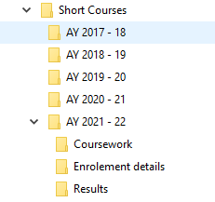
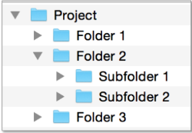

References
- Essential Records Management (A guide to managing electronic records using existing infrastructures and resources) The National Archives
- Managing Records: a handbook of principles and practice Elizabeth Shepherd and Geoffrey Yeo 2003
- DIRKS – The DIRKS Methodology: A Users Guide Part 1
- DIRKS – A Strategic Approach to Managing Business Information Part 2 Steps A-H

