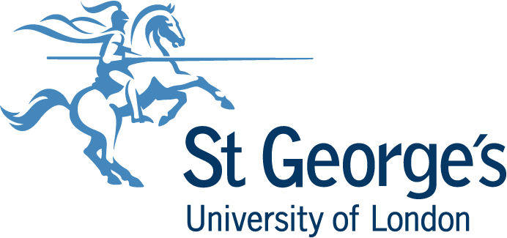

Council Away Day

17 May 2019

The Law Society
113 Chancery Lane
London
WC2A 1PL

Council Away Day Agenda – 17 May 2019

Time | Session | Presenters
9.00 – 9.30 am | Refreshments
9.30 – 10.00 am | Opening remarks from the Chair  Principal’s Introduction – Busy, but in the right ways? | Michael Draper, Chair of Council  Professor Jenny Higham, Principal
10.00 – 11.00 am | Engaging with a Wider Community  (including Queen’s Anniversary Prizes/Public Engagement developments/school’s outreach)  Civic Universities Report (attached)  Discussion/Feedback (20 minutes) | Professor Deborah Bowman, Deputy Principal (Institutional Affairs)  Professor Julian Ma, Director, Institute of Infection and Immunity
11.00 – 11.40 am | Extraordinary Meeting of Council  Access and Participation Plan  A presentation and discussion  Followed by formal approval by Council  Access and Participation Plan (attached) | Jess Bond, Head of Widening Participation  Dr Rosie MacLachlan, Associate Dean for Access and Participation
11.40 - 12.00 pm | Refreshments | Council Photograph
12.00 -12.30 pm | Pensions – Potential Impacts | Nicola Arnold, Director of Finance/Cara Wright, Payroll and Pensions Manager
12.30 – 1.00 pm | Student Perspectives | President, Students’ Union
1.00 – 1.45 pm | Lunch
1.45 – 3.15 pm | Research: New views?  Research on the campus & beyond  REF: We are preparing…….  Discussion/Reflections/Feedback on Research (20 minutes) | Professor Jon Friedland, Deputy Principal (Research)  Professor Jodi Lindsay, REF Lead
3.15 – 3.30 pm | Refreshments
3.30 – 5.00 pm | Educational Diversification  International perspective  Partnerships and Quality Assurance  Online distance learning  Discussion/Reflections/Feedback on Education (20 minutes) | Chair - Prof Jane Saffell, Deputy Principal (Education)  Naz Hussain, Associate Director of Marketing and Student Recruitment  Professor Cilla Harries, Associate Dean Research & Enterprise (FHSCE)  Dr Ferran Valderama, Erasmus Programme Lead  Derek Baldwinson, Director of Quality and Partnerships  Professor Kate Tatton-Brown, Academic Lead for Postgraduate Curriculum Innovation  Luke Woodham, Technical Innovations Manager  Bryony Williams, Learning Technology Services.
5.00 – 6.00 pm | Drinks
Participants:

Council Members

Professor Deborah Bowman
Mr Anthony Bicknell
Mr David Carter
Mr Michael Draper (Chair)
Professor Jon Friedland
Dr John Hammond
Professor Sian Harding
Mr Omar Hajazi
Professor Jenny Higham
Dr Sally Jackson
Mr Josh Joshi
Dr Rima Makarem
Mr Ken Morrison
Ms Gillian Norton
Dr Aileen O’Brien
Ms Sue Rimmer
Professor Jane Saffell
Professor Steven Spier
Ms Catherine Swarbrick
Mr Ewart Wooldridge

Apologies

Mr Damian Reid

In attendance:

Nicola Arnold
Derek Bannister
Sian Marshall
Paul Ratcliffe
Susan Trubshaw
Jenny Winters

Additional Participants

Mr Derek Baldwinson
Ms Jess Bond
Professor Jodi Lindsay
Professor Cilla Harries
Mr Naz Hussain
Professor Andy Kent
Professor Julian Ma
Dr Rosie MacLachlan
Professor Kate Tatton-Brown
Dr Ferran Valderama
Ms Bryony Williams
Mr Luke Woodham
Ms Cara Wright

