Something the Lord made

The study of medicine is in many ways a study of names. It is rich with mysterious eponyms that echo through lecture theatres and carve out chapters in textbooks. They are footnotes from the golden age of medical discovery that hark back to those great thinkers, ensuring their legacies live on. But, as is the nature of history, some names are less likely to be remembered than others.
The year is 1940 and a 20-year-old Denton Cooley is about to commence his medical studies at Johns Hopkins University. The name may ring a bell, as Cooley would later establish himself as the world’s foremost cardiothoracic surgeon by performing the first total artificial heart implantation in 1969 (1). In that same year of 1940 Hopkins would employ a new surgeon-in-chief, Dr Alfred Blalock, whose pioneering research on haemorrhagic shock was already saving lives on the battlefields of World War II.
But the name we are interested in is not Cooley or Blalock. It is Vivien Thomas, Blalock’s young black research assistant. Thomas grew up in Nashville, Tennessee. At 19 he was working as a carpentry assistant saving up to move onto college and then medical school. However his plans were stymied by the Great Depression which wiped out his savings and stunted Nashville’s carpentry industry (2). With his employment in limbo, he took a job as a lab assistant under Blalock who at the time was conducting shock experiments at Vanderbilt University.
With no post-high school education Thomas faced a steep learning curve, but absorbed everything taught to him about anatomy and physiology by research fellow Dr Joseph Beard. He swiftly became Blalock’s right-hand man, and was entrusted with designing complicated experiments to test Blalock’s theories. The two would remain in the lab long after everyone had left, overseeing experiments and discussing results into the night. The breakthrough came when their observations of the canine vasculature revealed that the cause of traumatic shock was third-spacing of plasma into the interstitium (3). While this may appear elementary to even a first-year medical student today, at the time it flew in the face of the established theory that shock was caused by an endogenous toxin released upon trauma to the tissues, and sparked heated debates between Blalock and his contemporaries (4). This discovery ushered in a new era of plasma transfusion therapies and laid the foundations for today’s clinical management of shock.
With his profile now raised, job offers for Blalock abounded. But by now Thomas had proven himself indispensable and Blalock refused to relocate without him, leading to difficulties as it was commonplace for institutions to have policies against hiring black employees. Thomas faced discrimination on multiple fronts. His name was not included on the research papers that he played a crucial role in producing, and despite doing the work of a post-doctoral fellow, he was classed as a janitorial employee with his salary reflecting this. For extra income he would work as a bartender at Blalock’s parties, facing the strange situation of serving drinks at night to students whom during the day he had been instructing (5). Eventually, Johns Hopkins agreed to take on both Blalock and Thomas, and it was at Hopkins that Thomas would cement his legacy.

Dr Helen Taussig was a cardiologist who came to the researchers in 1943 seeking help with cyanotic infants who were dying of hypoxia soon after birth. She suggested there may be a surgical solution, and Thomas realised that the key might lie in an old unsuccessful Vanderbilt experiment. He and Blalock had been trying to induce pulmonary hypertension in their canine models by connecting the subclavian artery to the pulmonary artery, but this had ultimately failed. Thomas now realised, however, that this anatomical configuration would shunt blood from the arterial system back to the pulmonary vasculature to be re-oxygenated, theoretically alleviating the hypoxic infants’ symptoms.
But to test this theory Thomas needed to first produce the condition in the canine heart before subsequently correcting it. He studied congenitally deformed hearts in the pathology museum and mastered the anatomical anomalies that characterise the tetralogy of Fallot, completing over a year of experiments to hone his solution. This culminated in the first surgery for the condition in 1944 on baby Eileen Saxon. Alfred Blalock carried out the operation with Denton Cooley, now a surgical intern, assisting. Thomas, who had perfected the technique after dozens of iterations, stood on a step-stool behind Blalock and guided the procedure over his shoulder (6). The surgery is widely termed the Blalock-Taussig shunt, with Thomas’s name excluded.

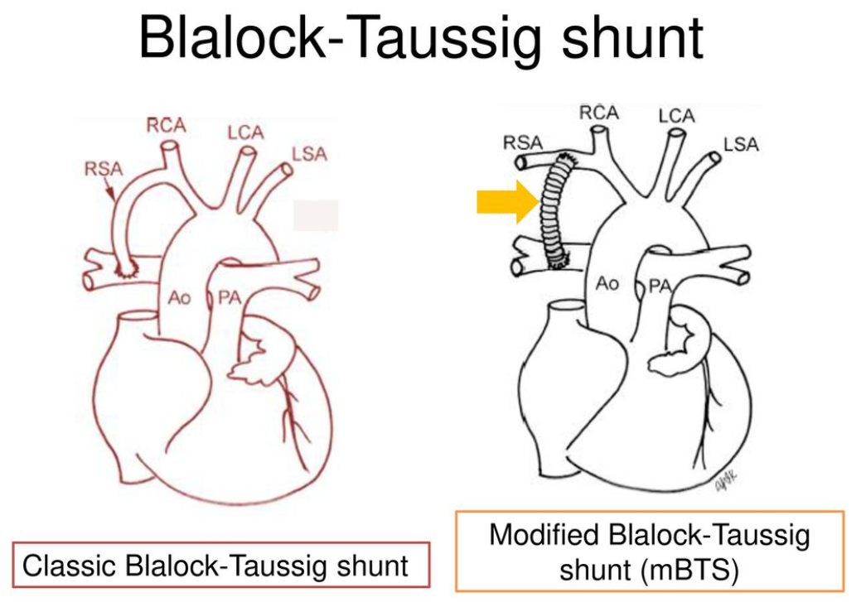
Figure 1: Classic Blalock-Thomas-Taussig shunt where a division of the right subclavian artery is grafted to the right pulmonary artery. The modified shunt procedure carried out in hospitals today uses ePTFE (Gore-Tex) tubing to form the anastomosis (7)(8).

Today a modified version of the Blalock-Thomas-Taussig shunt forms the first step in the three-stage Norwood procedure to correct hypoplastic left-heart syndrome, and other heart defects with single-ventricle physiology. Continuing to push the envelope, Thomas developed a procedure called the atrial septectomy to palliate dextro-transposition of the great arteries, another cause of neonatal cyanosis. Marvelling at Thomas’s flawless correction, Blalock famously remarked, “this looks like something the Lord made” (9).
Thomas’s contributions to medicine were eventually recognised in a ceremony at Hopkins in 1971, attended by the fathers of vascular surgery, who would come to be known as the Old Hands. Many of them were trained by Thomas himself. They presented him with a commissioned portrait which hangs opposite the portrait of Blalock in the lobby of the Alfred Blalock Building (9).
Thomas displayed an unrelenting work ethic as a researcher, and remarkable skill and dexterity as a surgeon. But ultimately it was his dynamic command of vascular anatomy that facilitated the synthesis of experiments that solved the puzzle of shock, and allowed him to fashion unprecedented anatomical corrections for congenital defects of the heart. Despite a lifetime of accomplishment, Thomas always privately lamented not having attended medical school, and in the latter years of his life Blalock also expressed regret at not helping Thomas fulfil this wish. But with the benefit of hindsight, the 1989 words (9) of Washingtonian journalist Katie McCabe come to mind: Vivien Thomas might have been a great surgeon. Instead, he became a legend.

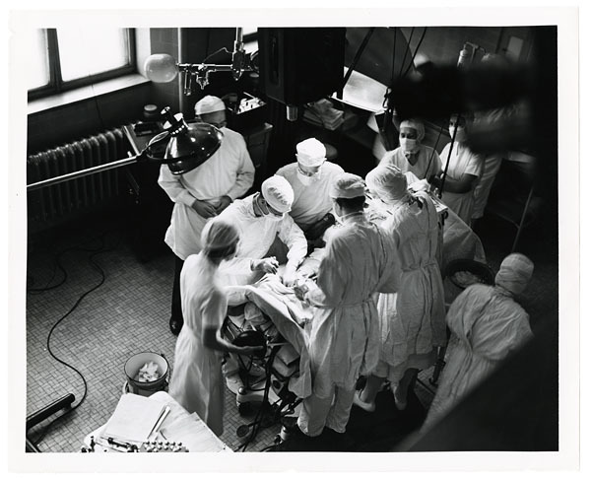
Figure 2: From the Alan Mason Chesney Medical Archives: Overhead view of a blue baby surgery in 1947 - Vivien Thomas (top left) standing just behind Alfred Blalock, overseeing the procedure (10).
References
1. World’s first artificial heart implant - archive | Health | The Guardian [Internet]. [cited 2021 Oct 17]. Available from: https://www.theguardian.com/society/2016/apr/07/heart-implant-artificial-haskell-karp-1969
2. The Great Depression in Tennessee - The Knoxville Focus [Internet]. [cited 2021 Oct 17]. Available from: https://knoxfocus.com/archives/great-depression-tennessee/
3. BLALOCK A. SHOCK: FURTHER STUDIES WITH PARTICULAR REFERENCE TO THE EFFECTS OF HEMORRHAGE. Arch Surg [Internet]. 1934 Nov 1 [cited 2021 Oct 17];29(5):837–57. Available from: https://jamanetwork.com/journals/jamasurgery/fullarticle/542068
4. Buchman TG. Shock: Blalock and Cannon. Arch Surg [Internet]. 2010 Apr 1 [cited 2021 Oct 17];145(4):393–4. Available from: https://jamanetwork.com/journals/jamasurgery/fullarticle/405830
5. Vivien T. Thomas: From Poverty to Pioneer - The Oxford Scientist [Internet]. [cited 2021 Oct 17]. Available from: https://oxsci.org/vivien-t-thomas-from-poverty-to-pioneer/
6. Cooley DA. The first Blalock–Taussig shunt. J Thorac Cardiovasc Surg [Internet]. 2010 Oct 1 [cited 2021 Oct 17];140(4):750–1. Available from: http://www.jtcvs.org/article/S0022522310006823/fulltext
7. Intern 柳孟鵑 Supervisor: VS 謝旻玲 - ppt download [Internet]. [cited 2021 Oct 17]. Available from: https://slideplayer.com/slide/12907885/]
8. Blalock-Taussig shunt | Radiology Reference Article | Radiopaedia.org [Internet]. [cited 2021 Oct 17]. Available from: https://radiopaedia.org/articles/blalock-taussig-shunt-2?lang=gb
9. The Remarkable Story of Vivien Thomas, the Black Man Who Helped Invent Heart Surgery [Internet]. [cited 2021 Oct 17]. Available from: https://www.washingtonian.com/2020/06/19/the-remarkable-story-of-vivien-thomas-the-black-man-who-helped-invent-heart-surgery/
10. Vivien Thomas · The Blue Baby Operation · Exhibits: The Sheridan Libraries and Museums [Internet]. [cited 2021 Oct 17]. Available from: https://exhibits.library.jhu.edu/exhibits/show/the-blue-baby-operation/vivien-thomas

