Workstation Set Up Diagram

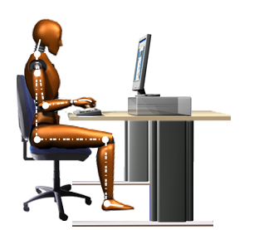

No excess pressure on underside of thighs and backs of knees

Seat back adjustable

Good lumbar support

Seat height adjustable

Shoulders relaxed

Arms bent at elbows at approximately 90 degrees

Forearms approximately horizontal

Screen height and angle adjusted to allow comfortable head position

Screen height dependent on typing style, tasks performed, software used and glasses worn

Space in front of keyboard to rest hands and arms when not typing

Space for postural change, no obstacles under desk

Foot support if needed

Wrists not bent (up, down or sideways)