Breathing Apparatus (BA) Maintenance Procedure

1 | 20/02/2009 | Draft issued for comments
Rev | Date | Amendment | Approved & Authorised by
Breathing Apparatus (BA) Maintenance Procedure

1.1 Summary (Breathing Apparatus Functions and Use) 3
1.2 Type and Location of BA Equipment 3
1.3 Training and Face Fit Testing 4
1.4 BA Kit Storage, Maintenance and responsibilities 4
(i) AFTER USE CARE 5
(ii) MONTHLY CHECKS 5
(iii) ANNUALLY 5
(iv) 6 MONTHLY 5
(v) 12 YEARLY 5
1.5 Cylinder Maintenance 5
(i) STRETCH TESTING 5
(ii) FILLING CYLINDERS 6
1.6 Contacts 6
Appendix I: Breathing Apparatus (BA) Monthly Checks 7
Appendix II: Breathing Apparatus (BA) Donning Procedure. 8

Procedure

1.1 Summary (Breathing Apparatus Functions and Use)
Respiratory protective equipment (RPE) is designed to be worn in a contaminated atmosphere and to provide the wearer with a safe supply of air. The control of exposure to hazardous substances should be achieved by means other than personal protective equipment where ever possible. Where this is not practicable and there is a likelihood of inhalation risks, suitable personal respiratory equipment should be provided. The need for RPE should be identified when risks in the workplace are assessed, such as through a COSHH risk assessment. An example of such a situation is in the event of a controlled release of a chemical agent, e.g. formaldehyde in the routine decontamination of microbiological safety cabinets.

ONLY TRAINED & FACE FIT TESTED EMPLOYEES SHOULD USE BA EQUIPMENT (See Training and Face Fit Testing)

1.2 Type and Location of BA Equipment
Breathing apparatus (BA) is a form of RPE that delivers breathable air from an independent source to the wearer. SGUL has maintained BA kit installed at key locations throughout Jenner.

BA Kit manufacturer | Cylinder Size (L) | Working Time (mins) | Location
CEN PAQ Waistcoat | 600 | 10 | BRF Building Level 0
CEN PAQ Waistcoat | 600 | 10 | Dissecting Room Level 0.1
CEN PAQ Waistcoat | 600 | 10 | Hotung Lab Level 2
SABRE Contour | 1800 | 33 | BRF Building Level 0
SABRE Contour | 1800 | 33 | Dissecting Room Level 0.1
SABRE Contour | 1800 | 33 | Hotung Lab Level 2

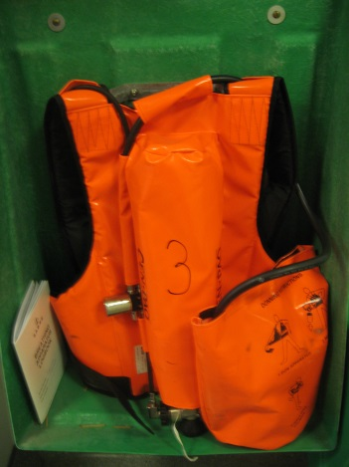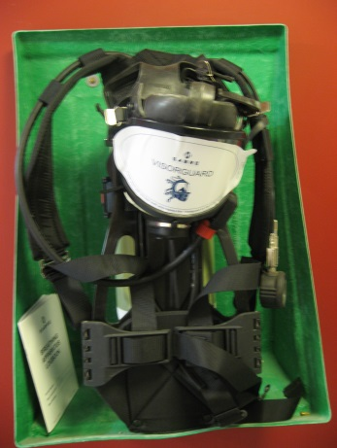
SABRE-CONTOURR
CEN-PAQ

1.3 Training and Face Fit Testing
Employees who are required to use respiratory equipment must be adequately trained. Training should:
- be specific to the equipment
- cover both the theory and the practice of using the various types of equipment
- cover maintenance
Training will be given to employees before they start to use the equipment, and followed by annual refresher training. If methods of work, safety procedures or equipment change then refresher training will be provided prior to the intended use. HSG53 The Selection, Use and Maintenance of Respiratory Protective Equipment outline specifically topics that should be covered by training.
Face Fit Testing is a BA requirement as outlined in the Approved Code of Practices (ACoP's) supporting COSHH Regulations 2002, The Control of Lead at Work Regulations 2002 and The Control of Asbestos at Work Regulations 2002. The HSE provide guidance in 'Fit Testing of Respiratory Protective Equipment Face pieces' (HSE OC 282/28). All new BA users will be subject to Face Fit Testing. Further testing may be required when:-
- New face pieces are purchased
- If an employee wears more than one type of tight fitting face piece then each face piece should be tested.
- A wearer loses or gains weight
- A wearer is subject to major facial changes e.g. dental surgery

1.4 BA Kit Storage, Maintenance and responsibilities
Storage:
Equipment installed at key areas is stored in dedicated cases mounted on walls that allow ease of access and ensure it is kept out of areas where it can become damaged.
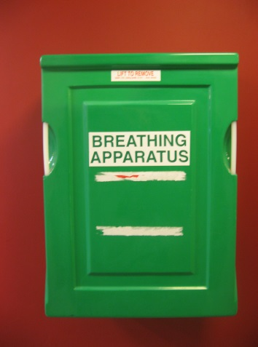
Maintenance:
Maintenance and testing of BA should be routinely carried out to insure the integrity of the kit.

(i) AFTER USE CARE
Suitable arrangements should ensure that no employee uses RPE which has previously been used by another person, unless it has been thoroughly washed and cleaned in accordance with the manufacturer's instructions. After washing, a thorough rinsing is essential to remove soap or detergent from the equipment. Only disinfectants recommended by the manufacturer of the equipment should be used. The equipment should then be thoroughly dried and reassembled Suitable disinfectant and disinfecting wipes are available from the SHE office.

(ii) MONTHLY CHECKS
In accordance to manufacturers recommendations and COSHH Regulations 2002 Approved Code of Practice and Guidance L5, thorough maintenance examinations and testing of items of RPE, other than one-shift disposable respirators, should be made at least once every month, and more frequently where the health risks and conditions of exposure are particularly severe. This will include both visual checks and practical checks.
Only designated trained personnel should complete monthly check. Results of check will be recorded in log books that are located with equipment. For SOP see Appendix I
BRF= Glyn Fisher / Will Murphy
Hotung = Bill Newman
Dissecting Room = Lynda Philipson / Philip Adds
(iii) ANNUALLY | } | Personnel trained for the purpose of performing complex intricate repairs will be contracted to carry out maintenance and testing of BA equipment at designated intervals This will be arranged by the SHE office.

(iv) 6 MONTHLY

(v) 12 YEARLY

1.5 Cylinder Maintenance

(i) STRETCH TESTING

BS EN 1968:2002 for Steel Gas Containers, and BS EN 1802:2002 for Aluminium Gas Containers stipulate:-

- gas cylinders be hydraulically tested by specialists every 5 years
- visually inspected every 2.5 years.
- the cylinder should have the test date stamped on it and have a stick-on label stating the date of the next test.
- the 'intended contents' must be clearly shown on the cylinder, such as Breathing Air, Nitrox or Trimix.

(ii) FILLING CYLINDERS

Once cylinders have been identified as requiring filling the SHE office will arrange replacement. Spare cylinders are kept in the gas cylinder store and empty cylinders will be dispatched in accordance to the Carriage of Dangerous Goods Regulations.

All records of BA equipment maintenance and testing will be held by the SHE office

1.6 Contacts

Michael Anderson: Arco Ltd. Tel: 08701298525. BA maintenance, hydraulic testing.
Ian Closton: Aquanaut Training Centre. Tel: 02085468882. Cylinder filling.

Appendix I: Breathing Apparatus (BA) Monthly Checks

Please note only trained members of staff to use.

Please note checks are the same for both large and small BA sets.

Remove BA sets and monthly log book from case.

Place on work surface.

1) Check Hydraulic test Certificate. Check this is current and stamped on cylinder and is recorded in monthly log book.

2) Visual check. Check all harnesses, back plates and hoses for signs of wear and tear or damage. Check face mask is not damaged, rubber seals are intact and visual panel is clean and free from damage. Fail if damage seen. Make sure that cylinder restraining straps are locked and tight.

3) Cylinder Pressure Test. Put BA set on, correctly fitting to the body. Do not place face mask on. Push Re-Set Button on demand valve (button on side of valve attached to face mask.). Ensure by-pass valve is in off position (red valve under demand valve). Open cylinder valve fully and read gauge. Gauge must read 160 bar or above, if below cylinder needs to be changed.

4) Positive Pressure Test. With cylinder valve in the open position, place Face Mask on and correctly fasten restraining straps. Take a sharp breath, this will activate the Demand valve and start the air flow. Gently lift mask from face to break the seal to ensure there is an outward flow of air. Replace mask. Hold Breath and listen for leaks.
Breathe normally and take a deep breath and push the Re-set Button (thus switching off air to mask). Loosen head restraining straps and remove mask.

5) Leak Test. Close cylinder valve (hold brake with one hand and turn valve to off position). Observe Gauge and if needle drops more than 10bar in 1 minute, the BA set fails test.

6) Warning Whistle Test. With cylinder valve shut and BA set primed with air, open By-Pass valve very slowly and monitor needle on gauge. Whistle should activate at 55 +/- 5 bar. If whistle goes off outside of range, fail test.

7) Shut all valves making sure BA set is empty of air in tubing. Complete log book and replace BA set and book back into its storage box.

Please note if BA set fails monthly test, please inform SH&E department (020 8725 5365/5765) immediately who will arranged for equipment to be serviced.

GAF March 14

Appendix II: Breathing Apparatus (BA) Donning Procedure.

Please note only trained members of staff to use.

Please note checks are the same for both large and small BA sets.

Remove BA sets and monthly log book from case.

1) Check Monthly checks are recorded in the log.

2) Visual check Check all harnesses, back plates and hoses for signs of wear and tear or damage. Check face mask is not damaged, rubber seals are intact and visual panel is clean and free from damage.

While putting the BA set on carry out the following checks:-

3) Cylinder Pressure Test. (carry out test as per Monthly checks SOP E08/0).

4) Positive Pressure Test. (carry out test as per Monthly checks SOP E08/0, BUT do not switch off air or remove mask).

5) Leak Test (face seal test). Take a deep breath and hold. Close cylinder. Observe gauge for ten seconds to see if needle drops whilst at same time listening for leaks
Note. If no leak detected move to next step. If leak detected open cylinder valve and re-adjust face mask and try again.

6) Warning Whistle Test. With cylinder valve still shut breathe out slowly and monitor needle on gauge. Whistle should activate at 55 +/- 5 bar. Once Whistle activates fully open cylinder valve

7) By Pass. Check By pass valve is operational by opening valve to check air flow. Close valve and confirm cylinder pressure with partner.

8) Proceed to carry out operation.
Note. Maximum working duration of BA sets is:-
Small = 10 minutes & Large = 30 minutes. This will depend on other factors like type of work and stress.

Please note if BA set fails any test, please inform SH&E department (020 8725 5365/5765) immediately who will arranged for equipment to be serviced.

REMEMBER 5 safety rules when working in BA.

- Never remove mask in toxic area.
- Check Cylinder contents on gauge at regular intervals
- NEVER wear BA set on own. Minimal 2 persons.
- Stay in visual or audible contact with other BA users
- If anything goes wrong with ONE BA user BOTH BA users get out.

GAF March 14

